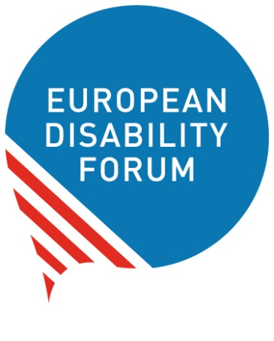

Our study about how technology
can help people with disabilities
to work
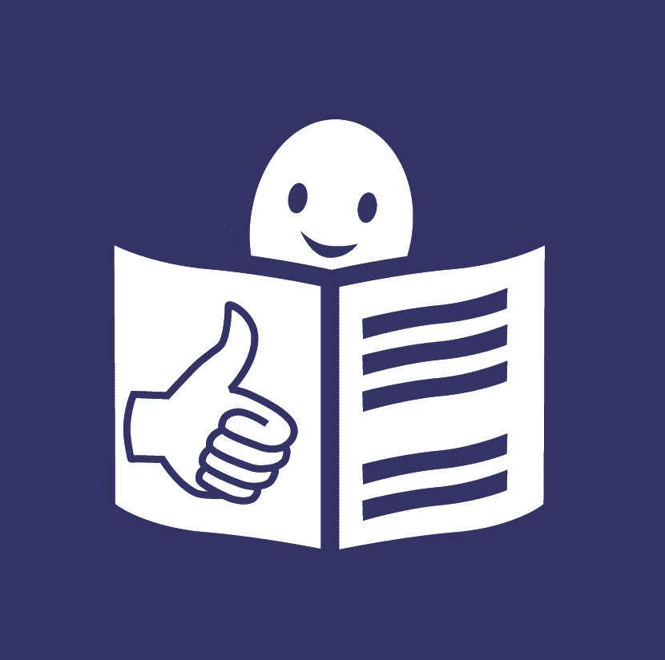
Easy-to-read version
Easy-to-read is information
that is written in a simple way
so that all people can understand it.
You can find more information
about easy-to-read at:
www.inclusion-europe.eu/easy-to-read.

The difficult words in the text are marked in bold.
You can find their explanation at the end of this booklet.

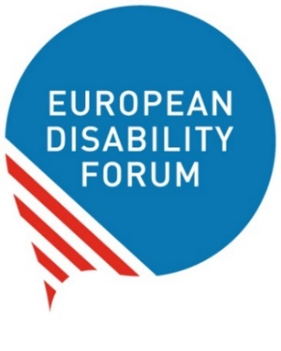
Who we are
We are the European Disability Forum.
We are an organisation
of people with disabilities in Europe.
In short, we are called ‘EDF’.
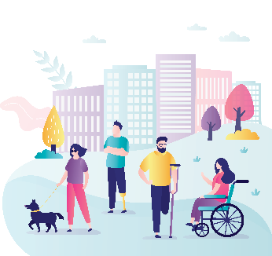
At EDF, we work to protect the rights
of all people with disabilities in Europe.
We think that people with disabilities
should have the same chances in life
and take part in the community
like everyone else.

Why we made this study
We made this study to check:
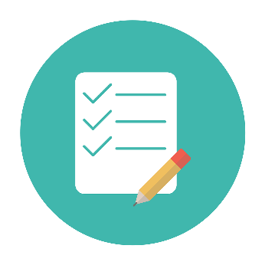
- How technology can help
people with disabilities to work,
- What the situation is
for people with disabilities in Europe,
- What can be better.
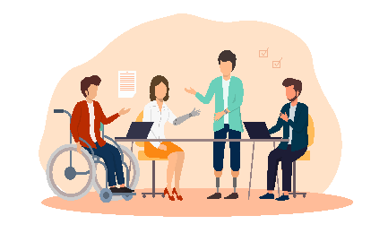
To make this study,
we asked for the views of people with disabilities and their organisations
in all countries of the European Union
and the United Kingdom.
We also asked for the views of employers
in these countries.
In the next few pages,
you will read what we learned from this study.

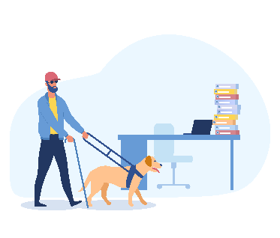
How technology can help people with disabilities to work
People with disabilities have the right to work
like all other people.
They should not be left out
because they have a disability.
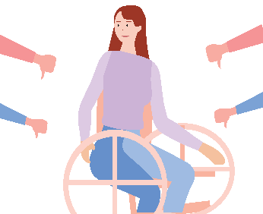
‘Assistive technology’ can help
people with disabilities
to work and do everyday activities
that would be hard or impossible to do otherwise.
Here are some examples of assistive technology:
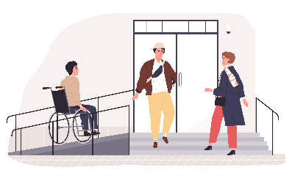
- Wheelchairs
A wheelchair helps people
who cannot walk
to get about.
- Hearing aids
Hearing aids help
people who do not hear well
to hear better.
- Braille keyboards
A keyboard with Braille can be used
by a blind person to type.
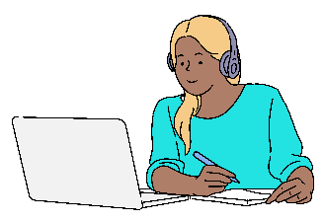
- Screen readers
This is a system that reads texts aloud
to people who have trouble
reading for themselves.
- Easy-to-read
Having information which is easy to read
makes it possible for everyone
to understand it without problems.
Having assistive technology is very important
because it helps people with disabilities
to work and to be independent.

What the situation is for people with disabilities in Europe
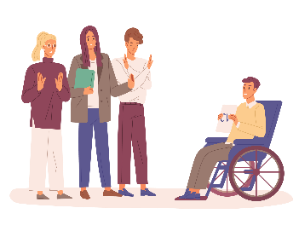
In practice,
almost half of people with disabilities in Europe
do not have a job.
But even those who have a job,
they may only work part-time and get little money.
Amongst other reasons,
our study showed that this can be because:
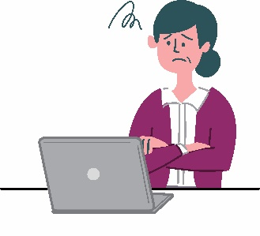
- Many people with disabilities in Europe may not know how to use technology.
They may also not know
that they have the right
to get the technology they need
to be able to work.
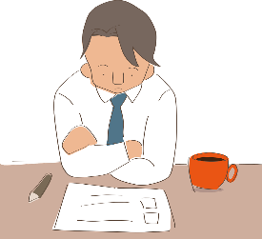
- The information and process to apply for a job
are often not accessible
to people with disabilities.
For example, the website
or application to fill in to apply for the job.
This means that people with disabilities
may not be able to apply for this job
like other people.
- Most employers do not understand
how they can hire people with disabilities.
Employers may be afraid it will cost them a lot to adjust the workplace to the needs
of people with disabilities.
This can be done by adding a ramp
that people in wheelchairs can use to get in,
having accessible toilets
and getting the technology
that people with disabilities need.
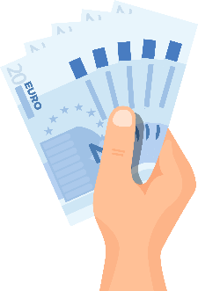
Also, employers may not know
that they can get money from their country
to make their workplace accessible.
But even if they know,
the process to get this money
may be long and difficult.

What can be better
Our study made it clear that
there are many things that can be better.

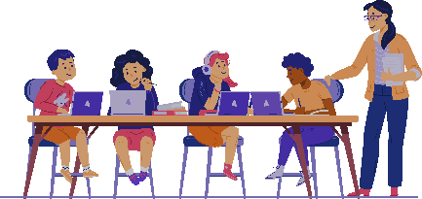
We ask countries in Europe to:
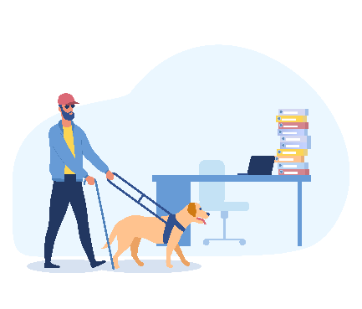
- Make sure schools teach children
how to use technology.
This way they will be able
to use technology at their work later on.
- Give more support to employers
to be able to make changes in the workplace
to meet the needs of people with disabilities.
- Let employers know
that they can get money and support
to make their workplaces accessible
to people with disabilities.

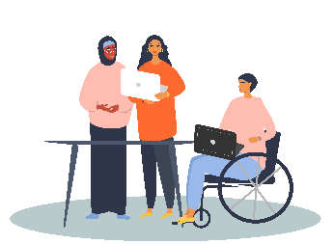
We ask employers to:
- Give training to people who work with them
to learn how to use technology.
- Make information and process
to apply for a job accessible
so that persons with disabilities
can apply like everyone else.
- Make changes in their workplace to fit the needs of people with disabilities and all people.
That could be:
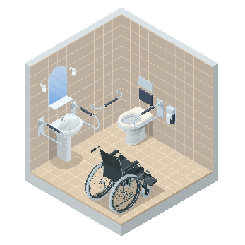
  - Making a ramp
that people in wheelchairs
can use to get in.
  - Having accessible toilets
that people with disabilities
can use.
  - Getting Braille keyboards
that blind people can use
to type.
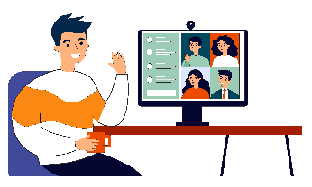
  - Allowing people with disabilities
to work from home
if it is hard for them
to get to the office every day.
  - Making information easy to read
so that all people
can understand it.

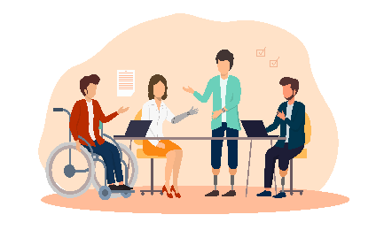
We ask companies that make assistive technology for people with disabilities to:
- Explain to employers
what assistive technology is
and how they can get it.
- Ask for the views of people with disabilities when they make new technology.
- Make technology cheaper
so that more people can afford to buy it.

Explanation of difficult words

Accessible
Things are accessible when they are easy to use for people with disabilities and all people.
For example,
when buildings have ramps
that people in wheelchairs can use to get in.
Or when information is easy to read
and all people can understand it.

Employer
Employer is a person or a company
who hires someone to do a job for them
and pays them a salary for this job.

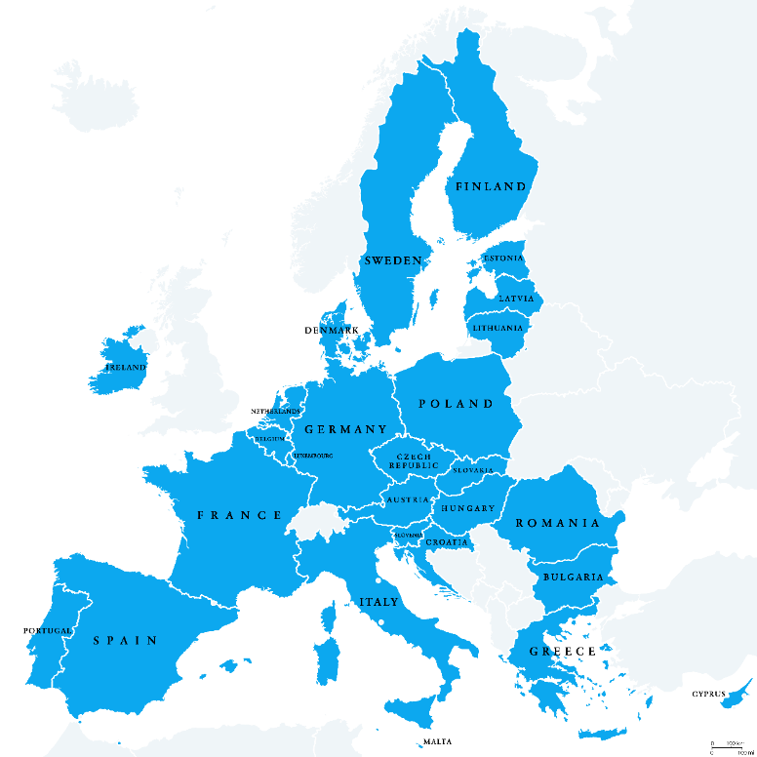
European Union
The European Union
is a group of 27 countries
in Europe.
These countries work together
to make things better
for their people.

