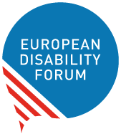 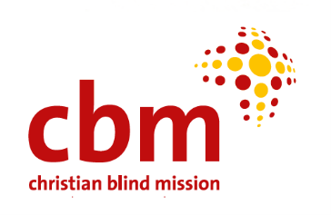
Brussels, 15 May 2024

Strategic Learning and Planning in the Ukraine Response: Meeting of EDF and Ukraine project implementing partners. Phase 2

Warsaw-Gdansk, Poland, 08-12 April 2024

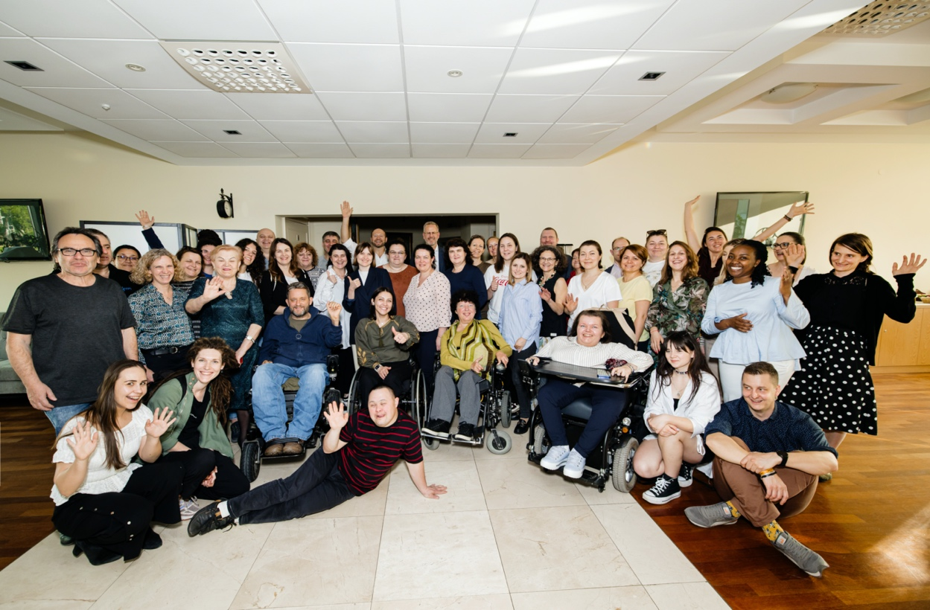

REPORT

Table of contents
Background 3
Summary 6
Aim and Objectives 7
Agenda and Approach 7
Participants: group and expectations 8
Accessibility 9
Meeting day by day 10
Follow-up activities planned by participants 16
Evaluation of the course by participants 18
Annexes 26

Background

About European Disability Forum
The European Disability Forum (EDF) is an independent organisation of persons with disabilities (OPD) that advocates for the rights of 100 million Europeans with disabilities. EDF is a unique platform that brings together representative organisations of persons with disabilities from across Europe. EDF is run by persons with disabilities and their families. EDF fights for a Europe where persons with disabilities are fully included in society on an equal basis with others and human rights, as outlined in the UN Convention on the Rights of Persons with Disabilities are fully respected, protected, and fulfilled. The main mission of the association is to ensure the full inclusion of persons with disabilities, and access to human rights through active involvement in policy development, implementation, and monitoring of the UN Convention on the Rights of Persons with Disabilities in Europe.

War in Ukraine
On February 24th, 2022, Russia launched a full-scale invasion of Ukraine, causing a humanitarian crisis that has seen over 6.3 million internally displaced people (IDPs) and returnees (4.4 million). Due to the systematic destruction of social and health infrastructure, the length of stay of IDPs and returnees is increasing. These increased needs in (barrier-free) accommodation and health services cannot be met by existing and destroyed structures at the community level. The already strained situation in psychosocial health is often interrupted, and access for people with disabilities is severely limited - although the need is particularly high among refugees and returnees with and without disabilities, as well as veterans. Due to a lack of employment opportunities and high inflation (26.6%), many population groups have humanitarian needs in the areas of food security and non-food items for daily life. Consequences are, for example, exploitation and increasing tensions in the host communities. People with disabilities live in about 29% of IDP households and people with chronic illnesses live in 44% of IDP households. Women and children with and without disabilities are disproportionately affected by the humanitarian crisis (violence, abuse, neglect). According to Ukrainian diplomatic services, the actual number of Ukrainian refugees in Poland is about 1 million people. Among them 49% of households have at least one member with chronic illness, 9% of households consist exclusively of older persons, 5% of household members are identified as persons with disabilities. Currently, there are 113,000 citizens of Ukraine in Moldova, approximately 10% of them being people with a certain form of “physical, sensory or mental disability”.

EDF and partners’ response
In March 2022, with the support of CBM International, EDF developed a Ukraine programme, to ensure persons with disabilities are included in the response to the war. Phase 1 of this programme Ukraine and seven of the neighbouring/nearby countries. From July 2023 the ￼￼HYPERLINK "https://www.edf-feph.org/projects/ukraine-war-opd-led-disability-inclusive-response-and-recovery-phase-2/"second phase of the programme￼ began, running for 18 months until December 2024. began, running for 18 months until December 2024.

Phase 2 project areas are Ukraine (Western and Central Region), Moldova, and Poland. In Ukraine EDF is strengthening OPDs and supporting IDPs and their host communities, in Moldova the focus is on capacity building of OPDs and support of Ukrainian refugees and their host communities. Additionally, EDF is collaborating with SUSTENTO (an EDF member OPD from Latvia) which is sending humanitarian aid in the form of care products, medicines, and necessary items for people with disabilities to Ukraine, conducting training of Ukrainian activists with disabilities in methods of implementation of Convention standards and works on the promotion of plain language in Ukraine. Inclusion Europe together with EDF’s experts contributes to the development of the system of self-advocates in Ukraine and the development of a strategy for the transition to community-level services instead of institutions. The Polish Disability Forum (PFON) is conducting trainings and other activities for Ukrainian and Polish OPDs supporting Ukrainian refugees in Poland. The project also has a component on the transition from the residential care system to community-level support and family education. In this area, EDF cooperates with Inclusion Europe.
The organisations involved, in alphabetical order by country, are:
Moldova: Motivatie, Centre for the Rights of Persons with Disabilities (CDPD), Society for Deaf Republic Moldova (ASRM) and the Alliance of Organisations for Persons with Disabilities (AOPD)
Poland: Polish Disability Forum (PFON) and Patchwork
Ukraine: National Assembly of Persons with Disabilities (NAPD), League of the Strong (LoS), Inclusion Europe and Latvian Umbrella Body for Disability Organisations (SUSTENTO)
The objective of this EDF programme is to ensure persons with disabilities and their representative organisations (OPDs) are supported in the response and recovery of the war in Ukraine. Specific objectives are
- to address immediate needs of all persons with disabilities in collaboration with organisations of persons with disabilities (ODPs),
- to ensure disability inclusion in the wider humanitarian response and reconstruction, and
- to strengthen the disability movement in the long-term to better respond to humanitarian needs.
Administration of the programme and the achievement of its objectives have been ensured through the involvement of relevant staff and experts.

EDF and partner collaboration and meetings
EDF and its partners are in constant contact as the programme is implemented. To maximise sharing of experience and learning, all organisations also meet online every month and discuss specific topics. During Phase 1 (in October 2022) all partners met in person in Brussels for a week of sharing, networking and planning. This event was repeated during Phase 2 in April 2024, in Poland (Warsaw and Gdansk).
For this week of meetings in Poland, the Polish project partner PFON was heavily involved, supporting all logistics and content specific to Poland, including coordination of guests from international organisations, Polish ministers and other institutions and experts. The agenda in general was developed according to specific requests from all partners.

Summary
From the 8 to 12 April 2024, the partners of Phase 2 of the EDF Ukraine response met in Poland (Warsaw and Gdansk) together with EDF and the donor, CBM International. The objectives were to enhance the implementation of the programme by learning from each other’s experiences, developing organisational and advocacy capabilities and planning for the future.
The group consisted of more than 50 people (including support and logistics staff) from all partners. External guests and experts from Disabled Peoples Organisation Denmark (DPOD), the German Agency for International Development (GIZ) also joined the meeting.
The Polish Disability Forum (PFON) supported EDF in all logistics and content preparation.
The overall experience was conceived as an opportunity to enhance the “team” atmosphere, to support the movement building in Eastern Europe, and to present partners’ successes. This has led to several moments where partners had to learn from each other experiences. For example, specific attention was paid to the Polish experience in accessibility, rehabilitation, independent living, and practical recommendations for introducing reforms in the field of rights of persons with disabilities, such as in the case of Poland’s accession to the EU.
The meeting format envisaged different activities where partners were able to work in groups, attend study visits, listen to panel discussions with guests, and participate in mini trainings and presentations on several topics. Moreover, the travel to Gdansk offered an optimal balance between work and fun which was important and requested from Ukrainian participants, due to the unusual psychological stress and work in wartime conditions.
Participants emphasised that the meeting provided a learning opportunity encouraged country and organisational follow-up actions and inspired new ideas:
“An inspiring meeting that made it possible to adopt experience and introduce opportunities for development in Ukraine.”.
“The impression is bright and positive. We received a lot of interesting and necessary information from the participants, we are establishing contacts, we plan to use the experience gained. Thank you for supporting Ukraine! We continue the effective cooperation of public organisations of persons with disabilities, international partners, and authorities, to strengthen the public movement in Ukraine for the sake of supporting people who find themselves in difficult living conditions, providing them with timely and effective humanitarian support. Thanks to all the organisers!”.

“We have to bring a broader approach towards different people who have barriers. We have to pull them down. I believe we can do it via this project and in the future. And for certain we can change the life of people with or without disabilities. Because we are all members of one universe, society, and community. Despite the fact we are living in different conditions, we have the same barriers and the same obstacles.”

Aim and Objectives
The main aim of the week of meetings was to enhance the implementation of the project by comprehensive and participatory meeting, learning, and planning with all implementing partners/members.
Specific objectives were:
- To share, learn, and plan together
- To foster a 'team' atmosphere
- To support disability movement building in the region
- To enhance the implementation of the Ukraine project

Agenda and Approach
The agenda (in Annexes) of the meeting was developed according to the general aim and specific objectives.
The agenda was prepared over several months and was based on the requests and ideas of partner OPDs. A brainstorming session was held in November 2023 regarding expectations and proposals. It was decided to split the agenda into two parts: half the time in Warsaw to meet with officials and the other half in Gdansk to discover best practices.
The working agenda started at 09:30 and ended at 17:30, including two breaks of half an hour and an hour for lunch. Each day had four sessions and/or time for personal reflections and moving to different locations. After the working agenda, free time or a joint dinner was included. Due to the logistics of different locations, some days had a different schedule. The arrival of the participants was planned the day before - April 7, and departure - after the end of the meeting - on April 12 in the afternoon, or on April 13.
The main approaches of the agenda were participation and experience of the participants: to give them the opportunity to present their successes, to explore the experiences of others, to have space for reflection and rest. Specific attention was paid to the Polish experience and practical recommendations for introducing reforms in the field of rights of persons with disabilities during the process of accession to the European Union. Working in groups, study visits, panel discussions with guests, mini-trainings, and presentations on topics relevant to the participants, change of environment, and moving to Gdansk, as well as enough free time and joint evenings, made it possible to create an optimal balance between work and fun. The latter is especially important for the Ukrainian part of the group due to the unusual psychological stress and work in wartime conditions.

Participants: group and expectations
The group consisted of 37 participants (2-4 representatives from each partner). Among them were 25 women and 12 men. Each OPD decided who would represent them, and most participants were local project coordinators or leaders of national / local OPDs.
External guests and experts from Disabled Peoples Organisation Denmark (DPOD), the German Agency for International Development (GIZ) also joined the meeting.
The Polish Disability Forum (PFON) supported EDF in all logistics and content preparation.
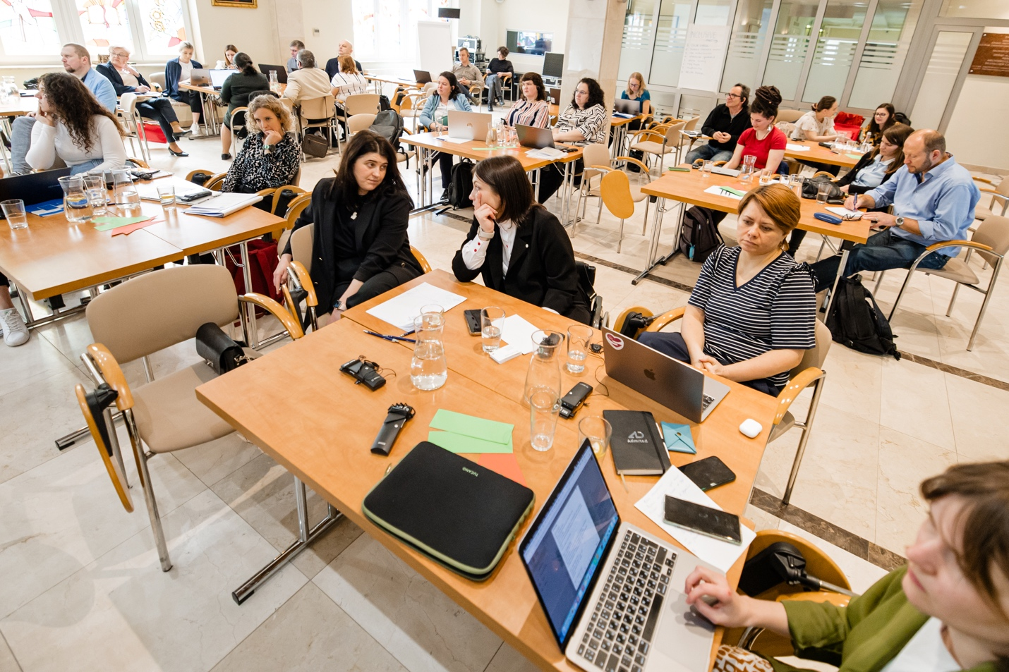Getting started. Plenary discussions during the first day of the meeting.
At the beginning of the meeting participants’ expectations were identified as follows:
- To talk to organisations of other countries to understand and share experiences about the challenges in Poland and to be on the radar for everything that happens, and to understand our experience and maybe to create something new together.
- To understand what the different components the programme has in our countries and at our level with the colleagues of Denmark.
- To start communicating with our colleagues from other countries to hear about their approach. To create new projects for the cooperation with EDF, and CBM for the reconstruction of Ukraine.
- The study visits - to learn how accessibility works, but also in the different partner organisations.
- To participate in different projects, and for example, we would like to open a café and to get some help and support.
- The long-term results and how to be effective on our activity and talk about taking into consideration the input of the rights of persons with disabilities in Ukraine.
- To learn more about participants’ organisations and activities and their involvement in the project and the successes and challenges.
- To have some bullet points and actions to continue, what we are going to do after this year.
- To have many conversations individually to talk about the challenges of the overall project.
- To reflect further on the future of community-based living for people with cognitive disabilities especially and to learn about the Polish concept (Gdansk experience).
- To create a network and have fun.
All of them were implemented, at least partially.

Accessibility
All meeting rooms (one in Warsaw and two in Gdansk) and participants' residences (two hotels in Warsaw and one hotel in Gdansk) had physical accessibility. The stay in each new space began with an introduction about the available security measures and the evacuation procedure in case of emergency.
The meeting was accompanied by a simultaneous interpretation (English-Polish, Ukrainian-Polish, English-Romanian), and live captioning in English. Some sessions and meetings were with sign language interpretation.
Personal assistants came with those participants who requested them. Most of them participated fully in the meetings.
One of the reasons to have this meeting in Poland was to check in practice level of accessibility in the country as a good example. Participants and organisers used public transport (tram, bus, and train to Gdansk), which was very accessible.

Meeting day by day

Day 1
The first day, Monday, began with the opening of the meeting: welcoming words, practical information, a round of names, an overview of the goal and objectives of the meeting, practical rules, and accessibility tools, as well as expectations of the participants and the agenda.
The next session was devoted to Upcoming topics and opportunities. In particular, the Warsaw Declaration was presented and opened for signing, as well as the preliminary results of the Phase 2 evaluation and the participants’ expectations regarding further work this. GIZ explained their plans and opportunities of the in the field of the rights of people with disabilities, in particular, information about the European Disability Summit, as well as partnership. DPOD presented opportunities as part of their new project aimed at supporting Ukrainians with disabilities in Ukraine and Moldova.
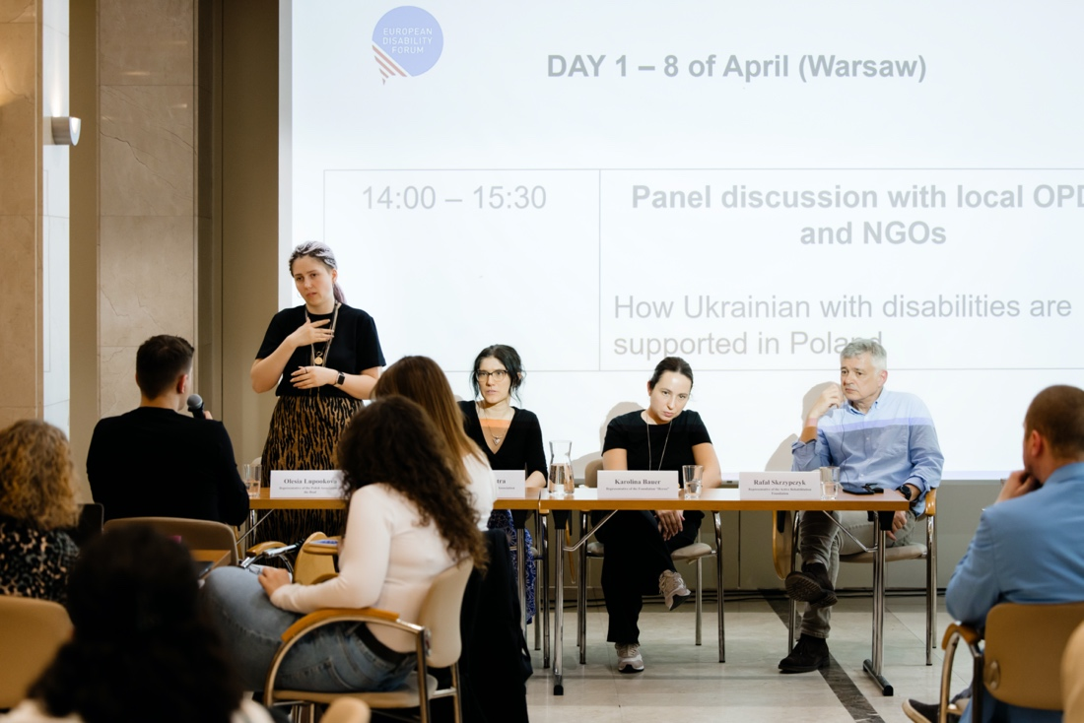
Hearing experience of Polish organisations working with Ukrainians with disabilities
After lunch, the participants had the opportunity to communicate with Polish organisations that support people with disabilities and protect their rights. The following persons took part in the panel discussion “What does support for people with disabilities from Ukraine in Poland look like in various organisations”:
- Olesia Lupookova - representative of the Polish Association of the Deaf - carries out activities for deaf people from Ukraine affected by the war
- Rafał Skrzypczyk - a person representing many organisations, but Vice-President of the Active Rehabilitation Foundation. He is personally involved in helping people with disabilities from Ukraine
- Karolina Bauer - representative of the Herosi Foundation - an organisation supporting people with oncological diseases from Ukraine
- Emilia Kustra - representative of the Mudita Association. She is involved in helping people with disabilities from Ukraine
The last session of the first day was dedicated to sharing experiences. Organisations had three rounds. During each round, four organisations talked about their experience and the biggest successes in their work. Each round began with the announcement of the organisations that would have presentations, the seats in the audience for them, and the available interpretation opportunities. Before their round, the organisations themselves presented the topic for conversation in one sentence - what kind of experience they wanted to share. The participants of each round were offered the opportunity to choose an organisation for conversation, which took 20-25 minutes. The participants chose different strategies: they helped each other with translation, voiced the presentations in two languages, or involved translators. There was a severe shortage of translators from Ukrainian to English (the available translators were Polish-Ukrainian and Polish-English, which was good for simultaneous translation, but limited consecutive). However, everyone managed to introduce themselves and get information about the work of others.
Participants submitted their presentations to be distributed among the group. Some examples of presentations and discussions are in the annexes.
The day ended with a ‘dinner in the dark’ at the restaurant "Different" - a place where waiters with visual impairments work.

Day 2
The second day, Tuesday, began with study visits. It was possible to visit one of the four organisations or to stay in the hotel and talk with the activists of the fifth. Information about organisations and available language options was provided in advance.
- Fundation Inne Spojrzenie. It is a non-profit organisation dedicated to supporting people with disabilities, both children and adults. Since 2021, they have been running the "Between Others" Support Center for adults on the autism spectrum. With Ukrainian language translator.
- MUDITA. The Mudita Association supports mothers of children with disabilities, as well as all others who care for their loved ones with disabilities daily. They speak in Ukrainian.
- Polish Deaf Association. The Polish Association of the Deaf aims to unite, integrate, and rehabilitate deaf and other hearing-impaired people, jointly solve their problems, and work towards equalizing developmental, educational, professional, and social opportunities. Organisation conduct many interesting and important projects. Among others, they helped Deaf people from Ukraine after the outbreak of war there. With English language translator.
- Foundation Aktywizacja. This organisation’s goal is to support people with disabilities in preparing for and entering the labour market. Foundation also helps employers create an inclusive work environment and recruit people with disabilities. They speak English.
- Foundation Active Rehabilitation (FAR). Since 1988, FAR has been running a comprehensive social and vocational activation program for people with permanent spinal cord injuries who use wheelchairs. FAR is active in helping refugees with disabilities from Ukraine both in Poland and Ukraine. They are helping these people find their way into the country after the outbreak of war.
The day before, the participants were divided into organisations for study visits (the limit was no more than 10 people in each). Visits together with the road (public transport was used) took almost two sessions. Participants mostly gave positive feedback about the visits. Some notes from the study visits are in the annexes.
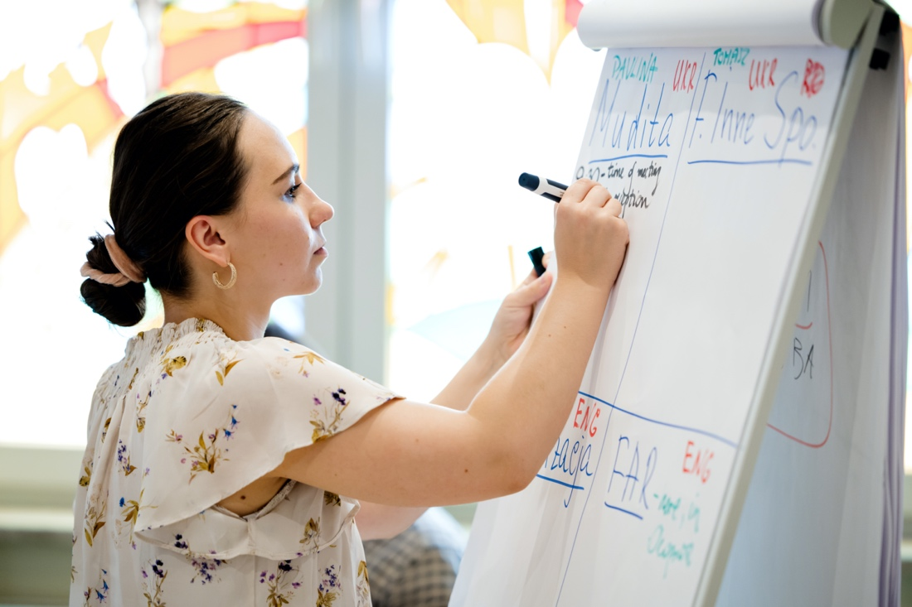
Paulina Sobolewska from PFON helps the participants to divide into groups for study visits
The second half of the day was devoted to meetings with Polish officials and international organisations. The topic "Support system for persons with disabilities in Poland – experiences, lessons learned and challenges" was presented by guests from the State Fund for Rehabilitation of Disabled Persons:
- Monika Rusin - Director of the Labor Market Department
- Kamil Bobek - Director of the Department for Cooperation with Non-Governmental Organisations
- Tomasz Kaca - head of the department for PFRON projects
From the speeches of the guests, the participants learned about the system of encouraging to hire people with disabilities, opportunities for support, rehabilitation, and socialisation, as well as how the state supports public organisations working in this field. Opportunities provided by Poland to Ukrainian refugees with disabilities were highlighted too. The main content of the speeches is in the annex.
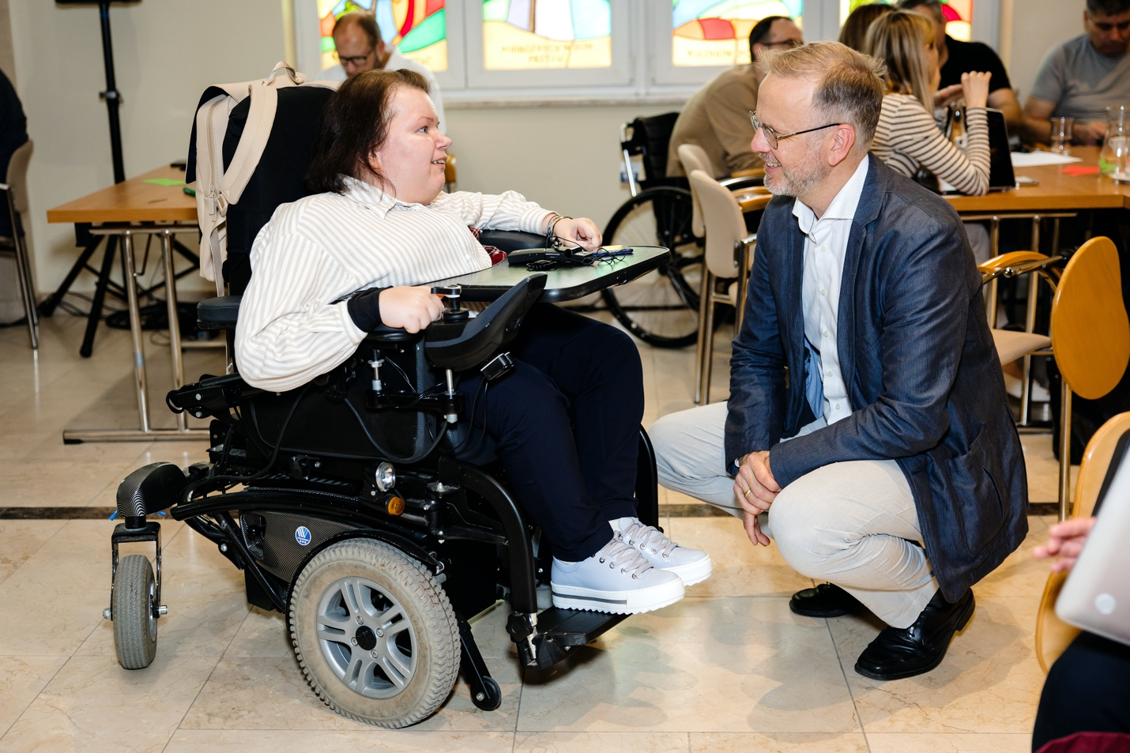Anna Drabarz from PFON talks to Jonas Grimheden from Frontex before the panel discussion
The topic of the next panel discussion was Mainstreaming a human rights perspective into humanitarian and emergency operations. Representatives of international organisations acted as guests and speakers:
- Gunta Anca – Vice President of European Disability Forum
- Prof. Jonas Grimheden, Fundamental Rights Officer, head of fundamental rights office, Frontex
- Speciose Kampire, Community-Based Protection Officer - UNHCR Polska
The guests talked with the participants about the general principles of international organisations' work and about including disability in this work. More information was received about Frontex and its potential involvement in the field of rights of people with disabilities (in the field of health care), as well as the work of UNHCR with refugees with disabilities and the results of a recent assessment of the needs of refugees with disabilities in Poland.

Day 3
The third day had one session - Accessibility and Rehabilitation in Poland - with invited guests:
- Łukasz Krasoń, Secretary of State, Government Plenipotentiary for People with Disabilities, Ministry of Family, Labor and Social Policy
- Przemysław Herman, Deputy Director, Department of the European Social Fund, Ministry of Development Funds and Regional Policy
- Katarzyna Krysik - Director of Accessibility Department, State Fund for Rehabilitation of Disabled Persons
- Tomasz Wojakowski - Plenipotentiary of the President of the Management Board of PFRON for Accessibility
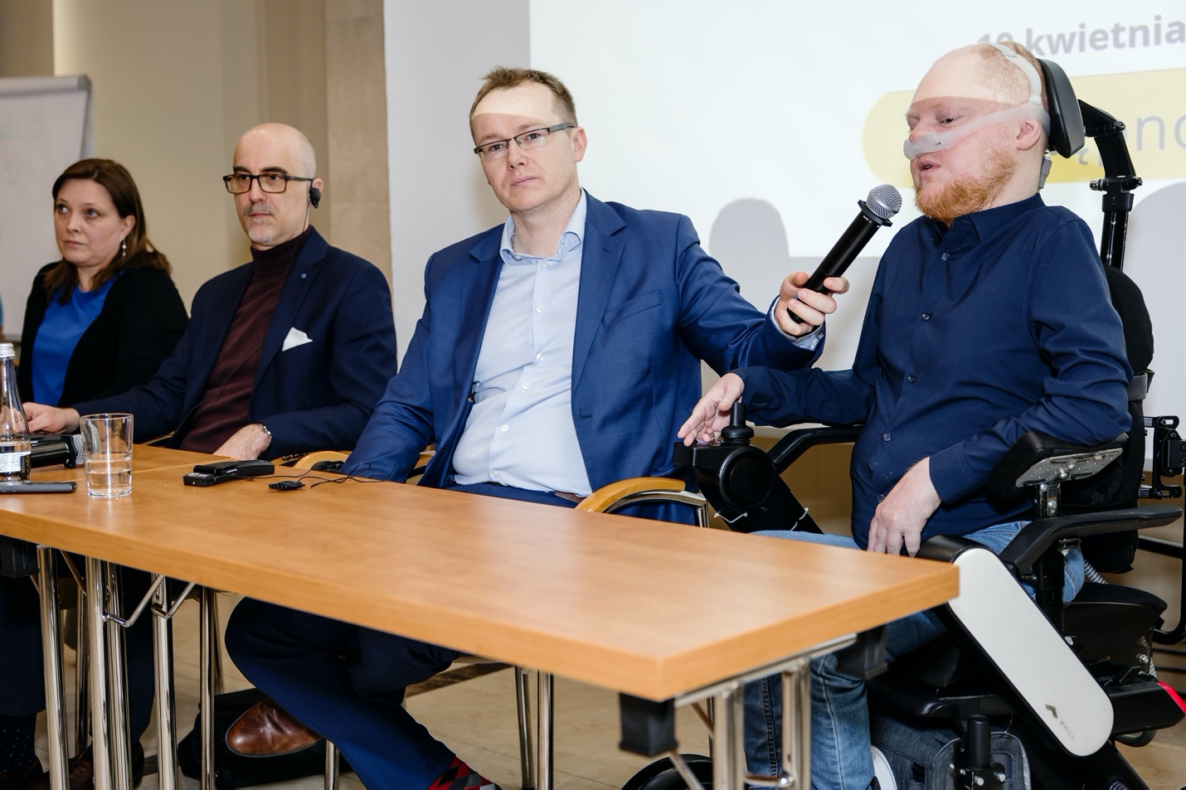Panel discussion Accessibility and Rehabilitation in Poland
During the meeting, the issues of accessibility in Poland (not only physical but, for example, during voting), the existing progress in comparison with other countries, and how political changes can be used for transformations in the field of rights of people with disabilities were discussed. Available calls were also indicated, as was personal assistant service. The important message was: The state is not money, it is services. The history of the process, including the introduction of anti-discrimination legislation and its practical application, was also highlighted. From there, through advocacy and ensuring participation, accessibility came as a basis for ensuring the realization of human rights for persons with disabilities. European Union funds were used for this purpose.
The session caused lively discussion and great interest among the participants.
After that, the group travelled to Gdańsk. This trip became an element of accessibility research in Poland: it was made by public transport (tram and train) and was fully accessible for participants with disabilities.
Upon arrival in Gdańsk and accommodation in the hotel, the participants had free time.

Day 4
The fourth day was entirely spent at the Polish Association for Persons with Intellectual Disability (PSONI). From the beginning, the participants were introduced to the work of the Association (including day centre, supported accommodation, education, work with parents, self-advocacy). Then there was a joint discussion about the transition from the institutional system of care for children and adults with disabilities to independent living and services at the community level. Speakers were representatives of PSONI, as well as Milan Šveřepa from Inclusion Europe and Marianna Onufryk - EDF's consultant working with the same issues in Ukraine.
The last session of the day was training on self-advocacy. Self-advocates from the PSONI and Vasyl Myryavchyk (Inclusion Ukraine) spoke before the participants. They shared their own experience of self-advocacy. The methodological part was also presented by Milan Šveřepa and Milena Johnová of Inclusion Europe.
After that, the participants had free time, and in the evening they had a joint dinner in the city.

Day 5
The last day of work was devoted to planning further actions. Participants in three groups discussed possible joint and individual actions in the field of continuing direct assistance to Ukrainians with disabilities affected by the war, advocacy for the observance of the rights of people with disabilities and strengthening the movement of people with disabilities in the region. The results of the participants are presented in the next section. An evaluation of the event and a final summary were also carried out.

Follow-up activities planned by participants
As a result of the meeting, participants have developed a list of ideas about what they are planning to do soon (on the country level and internationally).
Capacity building, straightness of OPDs, and disability movement in the region:
- To create a hub, a structure, or a department, established within the existing platform, the European Disability Forum. To connect the big platforms from every country, particularly for the non-EU member states. That will be part of this structure. Next step would be the strategy and the policy of this structure that will have to be developed along with the fundraising plan. National disability strategies. Cooperation and the connection of older organisations and new ones. Experience exchange opportunities. Best practice. Lessons learned. Expertise. Trainings: how to provide services at the EU level, self-advocacy as a tool, the training of OPDs staff.
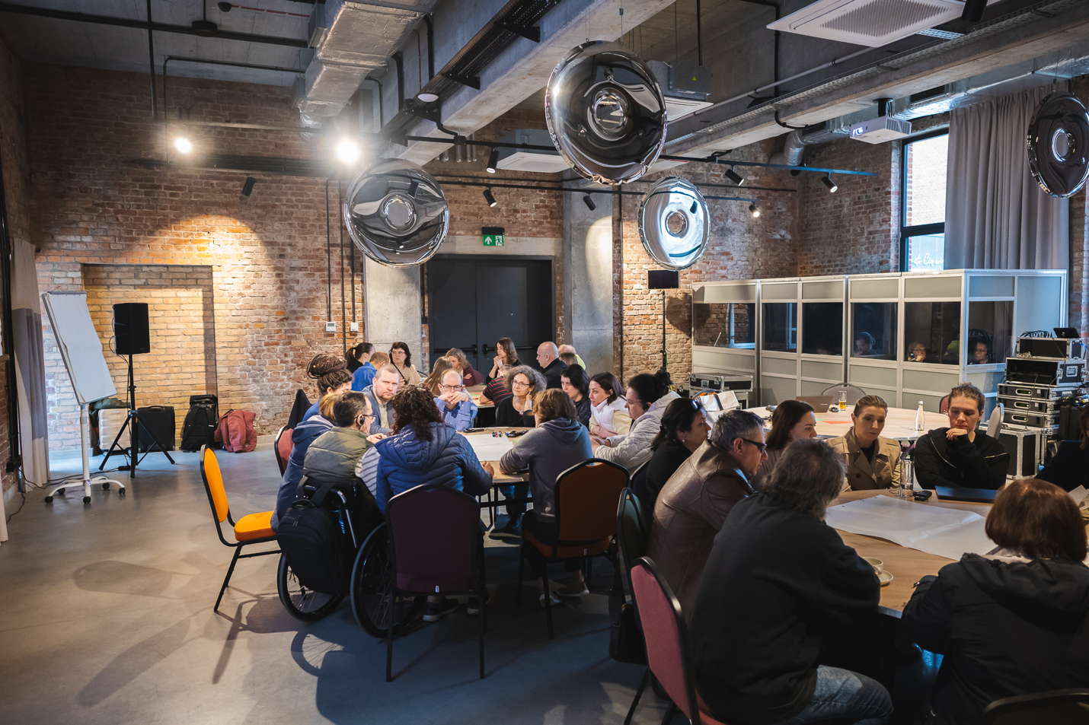Group discussions when planning the next steps

Advocacy campaigns and public actions for Moldova and Ukraine:
- Human rights approach to disability should replace the current medical one
- Accessible services for people with disabilities and rehabilitation on the local level, including planning relevant financial support
- Independent monitoring (in particular CRPD art. 22, private life and art. 19, independent living), informational campaigns
- Participation of people with disability in decision-making processes, including accession to the EU
- Accessible recovery processes in Ukraine
Humanitarian response and basic needs of people with disabilities in Ukraine and Ukrainian refugees with disabilities:
- Needs assessments of the people with disabilities and Ukrainian refugees
- Protection, integration, inclusion: education, language, training, information, accessible infrastructure, practical support, assistive technology, specific food items, employment
- Skills development: supported living arrangements, practical skills to have independent life, deinstitutionalisation, general principle of Nothing about us, without us
- Humanitarian preparedness and mainstream disability in the humanitarian response
- Logistic support and networking. Humanitarian preparedness
- OPD's have to be included in the monitoring of humanitarian actions
- Education and trainings for kay humanitarian actors
Collaboration with veterans and their organisations: all OPDs and organisations of veterans to join together, to find common solutions to common problems (for example, to have common camps, that include both people with disabilities, veterans with disabilities, and their families)
Also, the participants developed separate ideas at the individual level and marked them in the evaluation form. These ideas include:
- Implementation of experience in helping people with disabilities to find work
- Creation of a carpentry shop for people with disabilities, continuation of the introduction of supported accommodation, creation of a sewing factory, creation of a barrier-free space
- To carry out advocacy actions, which now are extremely necessary for our country
- E-learning
- Structuring the advocacy campaign for the establishment of the independent monitoring mechanism CRPD art. 33 para. 3A
- To train and teach people in my organisation
- Analysing challenges of iPads and best practices from other countries
With Phase 2 ending in 2024, resource sourcing was an important issue to discuss. The following were named among the potential sources of funding:
- EU funds
- State social order for service providers
- Crowdfunding
Three OPDs from Ukraine and Moldova have plans for collaboration with DPOD this year.

Evaluation of the course by participants
Evaluation of the meeting was done in two stages - group and individual. The group evaluation was very positive, participants emphasised that the meeting provided a learning opportunity, encouraged country and organisational follow-up actions, and inspired new ideas. Feedback included the following quotes:
“At the beginning, we were stressed. Because of the lack of communication. But with time, this contact was possible to be found and to communicate in different languages and different ways. And it makes us happy. We understand that if we want to find a common way, it is possible. It is possible to reach a common goal. It is said that we get only tasks with which we can deal. We can cope. With the whole group, we participated in preparing the Warsaw Declaration. We were talking about it, discussing it. We are advocating all the points in it. We wish you a good continuation."
“We have to bring a broader approach towards different people who have barriers. We have to pull them down. I believe we can do it via this project and in the future. And for certain we can change the life of people with or without disabilities. Because we are all members of one universe, society, and community. Despite the fact we are living in different conditions, we have the same barriers and the same obstacles. Thank you to CBM, for organisations from different countries, for everybody who inspires us, who gives us the possibility to continue to go on. We must pull them down. When we were here in Ukraine, 80% of the energetic structure was destroyed. It will be difficult to reconstruct until next winter. So, we are looking forward to a hot summer. We realise it will be a big problem for people with disabilities, due to lack of air conditioning. We won't have enough energy in Ukraine. We must concentrate on saving what's left and people's lives. We can't afford people dying because of lack of energy and because of lack of possibility of having operations in hospitals and so on. I would like to express my big thanks to everybody in this room. I would like to thank you for the fact that we can participate in this joint project where human beings are in the centre.”
“I was delegated on behalf of Moldova's group to this visit. We would like to thank you for this opportunity offered to all participants in this event. For all these opportunities to participate in the program, for the conditions you have provided, for your time, for the warmth and the good mood you created for us. You are the greatest, you are the best in this area. And EDF is a platform for people with disabilities. A platform that indeed promotes through all its actions. It promotes this feeling, this concept of the principles of the convention. Nothing about us, without us. And we thank Poland, we thank the Polish organisations for hosting us. For providing us, with all the conditions we needed, for a good stay here in Poland. Thank you so much. We will meet again surely. And we will discuss how things evolved and changed, including because of what will be put today in the paper. Of the thoughts and actions, we tried to identify as a priority for the organisations of people with disabilities. Also, to colleagues from Ukraine I would like to say the organisations present here in this room, are those organisations that provide services to people with disabilities. Namely Ukrainian refugees with disabilities. Speaking about the Centre of Rights for People with Disabilities, last year through our organisation we provided services. Legal support and individual support. To more than 1000 Ukrainian citizens. Only last year. Thank you so much.”
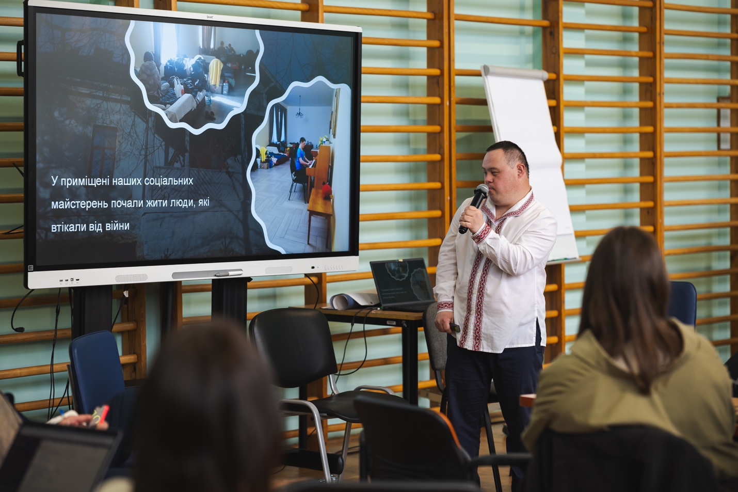Vasyl Myryavchyk talks about his self-advocacy experience and his organisation
“Well, for me this week was a full week. I could detach from my ordinary activities. What I do on an ordinary basis, in Moldova. I had to rethink this process and rethink my activities. I collected a lot of ideas. Thank you for being so open. Thank you for the logistical organisation, and the logistical team that organised for us an excellent study visits to Poland. And made it possible for us to have this exchange of experience. Since we were talking about advocacy in Ukraine and Moldova. For me, I understand this is a new challenge. We will have to rethink the process in such a way as we understand how we can be more heard at the EU level. So, that we can have a joined roadmap. We are different, but we have the same values. The European Union is the first value system. I understand it will be a challenge for EDF also. Thank you for everything you have done for us. And every end marks a new beginning. We will rethink the processes so we can propose a strong advocacy voice at the European level to include the disability dimension. In all the policies, developed and implemented at the level of Europe.”
“I thank my colleagues from Moldova and other countries. And a great thanks to EDF for supporting us in building an access ramp to our new office and house. Without your support, it would have been much more difficult for us. In our organisation we have some people with disabilities working there and coming to work daily. They use this access ramp. Also, when our beneficiaries come to our organisation and don't have access or they have difficulties accessing, for us this is not acceptable. Therefore, we keep promoting accessibility in our country. Because it is very important. Besides, the state is obliged to provide accessibility. Unfortunately, it is not respected. When we provide consultancy or support to young people to continue their education. They finish their education, and they stop there. Because they think, if they can go to the capital to continue their education, they will face several obstacles like the lack of ramps. This is not acceptable to us. We encourage people in charge to consider that people with disabilities should not be discriminated against. We continue fighting and protecting their rights. Thank you EDF once again, from the colleagues from the alliance. Also, a big thank you from people with disabilities. Whenever I visit an institution that is accessible, thank you to the administrators of the institution. Where I go and face obstacles I think, give mind and logic to those who are building, and make them think nobody is ensured about tomorrow. Tomorrow can bring unpleasant surprises to them. Patience and courage to all of us. We should not allow those who try to discriminate against us or to reach their goals without considering us. Thank you, the organisers. I highly appreciated that I had no obstacles here. I was thinking, what can I find here? Maybe some obstacles. I said initially I would not go to Poland. Maybe other people could go. In Moldova I am an accessibility evaluator, I make reports and designs. I was encouraging other colleagues to come to Poland. After all, I came here. And I say, no regrets for the fact that I came here. I saw nice people. I met positive people. I saw nice experiences that I am going to promote in Moldova. I collected new information for myself. This visit was accessible for me. Thank you so much.”
“I would also like to thank you on behalf of mine. Persons with this kind of disability do need support. Some organisations neglect our needs. I have a friend. He faces similar challenges. I wish to help him. The same goes for other people with intellectual disabilities. Let me tell you one thing. Let's do it all together. I'll keep repeating that. I'll keep inviting everybody to cooperate with our organisation. Huge thanks to the organisers. Thank you for the fact that Poland and all the EDF members have been co-creating similar conferences. I hope that there will be more of these kinds of events organised in the future. We need to shape the world. So that it works the way we would like it to.”
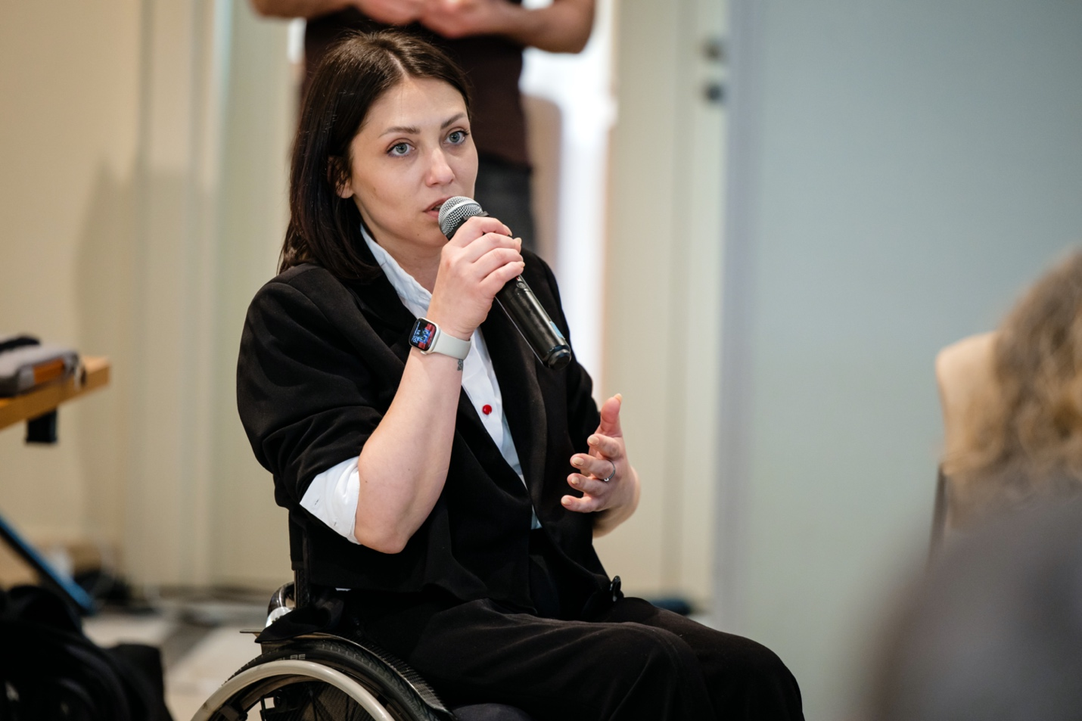Ulyana Pcholkina asks questions on the first day of the meeting
Individual evaluation through the evaluation form is also positive with some critical remarks. We received 26 evaluation forms.
The participants had to evaluate their satisfaction with the meeting and its components by answering questions:
- To what extent did the meeting satisfy your initial expectations?
- How valuable was it to share experiences with others?
- How useful were the training sessions?
- How practical and useful were the study visits in Warsaw and Gdańsk?
- How useful were the meetings with Polish officials and international organisations?
- How practical and useful were separate trainings and discussions?
The assessment had to be made on a 10-point scale, where 10 is the maximum level of satisfaction, and 0 is the minimum.
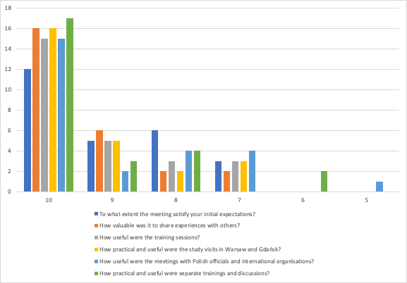
Level of satisfaction with the meeting and its components
In response to all questions, most participants chose the maximum score - 10. Only the question about meetings with Polish officials received one score of 5, and the question about separate trainings and discussions (in particular, about deinstitutionalisation) - 2 answers of 6 points each. This indicates the high satisfaction of the participants with the meeting and the proposed activities.
Almost all participants had a chance to present their OPDs, although not all were actively involved in the presentations (each organisation had at least two representatives and distributed presentation duties at its own discretion). Everyone received new ideas and plans for further cooperation with other participants. Participants gave honest and constructive criticism about sessions they thought less useful:
- “Session in PSONI in Gdańsk. We saw how complex could be support for persons with disabilities”
- “Deinstitutionalization. It was discussed excessively, trying to promote the idea that it is a top topic.”
- “Session on local organisations. It was not enough to describe the practical steps for future reforms.”
- “In first day to many presentations of Polish organisations. I wouldn't like to hear presentations of project partners.”
- “The session on Accessibility and Rehabilitation in Poland was the least useful because I have no experience with this topic.”
- “Discussion on deinstitutionalisation as my 30-year experience of DI advocacy confirms that for Ukraine DI talks remain talks which have very little to do with practices.”
- “The session about the exchange of our work and what we are doing in organisation was a little hard to understand how to quickly do it in groups. And I think that something from other session times it was good to reduce in time and dedicate the other time to our presentations and to talk more about our work. To understand each other better.”
- “Thursday morning in the Polish Association” (PSONI)
- “Accessibility and Rehabilitation in Poland.”
These comments will be considered in further work with partners, including during monthly meetings.
All participants left the meeting with ideas for further projects. Some of them are presented in the previous section. Half of the participants noted that they still need time to formulate ideas and discuss them with partners.
The participants highly appreciated the logistics, accommodation, and other facilities provided during the meeting. Some of the Ukrainian participants noted that working in two cities was difficult, mainly because of the difficult journey from Gdansk to Ukraine: “It would be logistically easier to start in Gdansk, or even one city at all”.
The organisers also received detailed advice on improving the logistics of events for people with disabilities with experience in organising such events by participants:
- “I think it's important to ask people with disabilities about walking distances if they can do this and prepare an alternative accessible way- transport. Some were very long.”
- “The logistics were somewhat complex for a person with an "invisible" disability which I have. E.g., it was too tiresome for me to travel 40 minutes one way on day 4 standing on the tram. Thus, I had to miss all the dinners and the appropriate part of informal communication as it was too tiresome. Next time you could consider the opportunity to have dinners in the place of accommodation.”
- “The agenda updates were at the very last minute. But nothing that made a problem of course. And maybe some advice: the restaurant in Warsaw was specific, for someone it should be planned by filling in a special form asking if you are ready to go there. I had some panic attacks in the darkness, but as everyone was there, I tried to calm down and relax. But it was stressful on a small level.”
- “In the future, I propose improving communication with participants during the events, because there was not enough information about changes in the schedule. This can be done by mail, updating, and informing about changes every time. Several times it was not at all clear where and when to come. I wanted more communication from the organisers, control from the managers, and whether everyone knew and understood where the next meeting was. There were inconsistencies with the schedule and events, and the written schedule, not words guided people.”
- “Consider longer lunch breaks. Half an hour for people with disabilities, who attended the forum, puts a person in front of a choice: eat/use the toilet / be late for the next session.”
- “Maybe next time also communicating changes in time by e-mail would be helpful.”
- “When forming events and groups of participants in the future, indicate in the announcements the need for the participation of translators as part of teams for effective communication outside the official sessions (this is for those cases when the participants do not speak English personally).”
Some general comments from participants:
- “It was a very friendly and open space to share experience, to meet organisation for the collaboration”
- “All was fantastic!”
- “I would like to more know about partners’ work and activities in this project.”
- “It was good to meet everyone, to talk to exchange. Thank you for organising everything and let's continue our work!”
- “An inspiring meeting that made it possible to adopt experience and introduce opportunities for development in Ukraine.”
- “I'm grateful for the opportunity to participate in this event. It helped me to connect, gain new perspectives, better understand challenges and good practices. Thank you!”
- “The impression is bright and positive. We received a lot of interesting and necessary information from the participants, we are establishing contacts, we plan to use the experience gained. Thank you for supporting Ukraine! We continue the effective cooperation of public organisations of persons with disabilities, international partners, and authorities, to strengthen the public movement in Ukraine for the sake of supporting people who find themselves in difficult living conditions, providing them with timely and effective humanitarian support. Thanks to all the organisers!”
For the organisers, this event was also a great practical lesson. These conclusions will be considered in further actions, and the recommendations given by the participants are already considered in the project's next activities and EDF's current work.

Annexes

List of participants
1 | AOPD | Climov | Galina
2 | AOPD | Prodan | Alina
3 | Asociația „MOTIVAȚIE” | Vdovicenco | Mihaela
4 | Asociația „MOTIVAȚIE” | Onofrei | Tudor
5 | ASRM | Koroli | Victor
6 | ASRM | Babici | Natalia
7 | CDPD | Mester | Vitalie
8 | CDPD | Mester | Marina
9 | EDF | Rattray | Gordon
10 | EDF | Morfaw Lekeanyi | Rene
11 | EDF | Ungureanu | Nicoleta
12 | EDF | Yasenovska | Mariya
13 | EDF | Tabirta | Valerian
14 | EDF | Traversi | Giulia
15 | EDF | Onufryk | Marianna
16 | Inclusion Europe | Johnová | Milena
17 | Inclusion Europe | Sverepa | Milan
18 | Inclusion Ukraine | Pryntsovska | Mariya
19 | Inclusion Ukraine | Myryavchyk | Vasyl
20 | Inclusion Ukraine All-Ukrainian NGO Coalition for Persons with Intellectual Disabilities | Kravchenko | Raisa
21 | NAPD | Petrusha | Svitlana
22 | NAPD | Polishchuk | Olena
23 | NAPD | Zaskaleta | Nataliia
24 | Patchwork | Bukhanovskaia | Mariia
25 | Patchwork | Ignatenko | Olga
26 | PFON | Taran | Aleksandra
27 | PFON | Drabarz | Anna
28 | PFON | Radwański | Adam
29 | PFON | Borawski | Blazej
30 | PFON | Sobolewska | Paulina
31 | PFON | Kurowski | Krzysztof
32 | PFON | Przybysz-Przybyszewski | Tomasz
33 | SUSTENTO | Chubarova | Niiara
34 | SUSTENTO | Veinberga | Daiga
35 | The League of the Strong | Kholod | Hanna
36 | The League of the Strong | Sydorenko | Daria
37 | The League of the Strong” | Pcholkina | Uliana
38 | SUSTENTO | Anca | Gunta
39 | SUSTENTO | Neimane | Iveta
40 | Translator | Ersov | Corina
41 | Translator | Sestacovschi | Diana
42 | DPOD | Lene | Aggernæs
43 | DPOD | Ina | Lykke Jensen
44 | GIZ | Tonn | Antje
45 | CBM | Schlott | Roland
46 | CBM | Duttle | Heimo
47 | CBM | Masuch | Laura
48 | CBM | Blöser | Julia
49 | Captioner | Gerbecks | Wilhelmus Jozephus
50 | Captioner | Haverhals | Veerle
51 | Evaluator | Green | Elaine

Daily Agenda
Day 1
Monday 8 April – Okopowa Centre, room S1
Time | Session
09:30 – 11:00 | Introduction
11:00 – 11:30 | Coffee break
11:30 – 13:00 | Upcoming topics and opportunities  - Warsaw declaration – Giulia Traversi EDF  - Evaluation – Elaine Green  - Disabled Peoples Organisation Denmark DPOD - Lene Aggernæs and Ina Lykke Jensen  - Tonn, Antje Deutsche Gesellschaft für Internationale Zusammenarbeit (GIZ)
13:00 – 14:00 | Lunch + PFON partners
14:00 – 15:30 | Panel discussion with local OPDs and NGOs  Olesia Lupookova - representative of the Polish Association of the Deaf  Rafał Skrzypczyk - Vice-President of the Active Rehabilitation Foundation  Karolina Bauer - representative of the Herosi Foundation  Emilia Kustra - representative of the Mudita Association
15:30 – 16:00 | Coffee break
16:00 – 17:30 | Sharing experience
19:30 | Dinner in town in restaurant “Different” - address: al. Jerozolimskie 123A/first floor (they have the lift), 02-017 Warszawa

Day 2
Tuesday 9 April – Okopowa Centre – room S1
Time | Session
09:00 – 13:00 | Study visits  Mudita, Fundacja Inne Spojrzenie  Fundacja Aktywizacja/Activation Foundation  FAR/ Active Rehabilitation Foundation,  Polski Związe Głuchych/ Polish association of the deaf
13:00 – 14:00 | Lunch in Okopowa Centrum
14:00 – 15:30 | Support system for persons with disabilities in Poland – experiences, lessons learnt and challenges – Okopowa Centrum  Representatives of the State Fund for Rehabilitation of Disabled Persons:  Monika Rusin - Director of the Labour Market Department  Kamil Bobek - Director of the Department for Cooperation with Non-Governmental Organisations  Tomasz Kaca - head of the department for PFRON projects
15:30 – 16:00 | Coffee-break
16:00 – 17:30 | Mainstreaming a human rights perspective into humanitarian and emergency operations  Gunta Anca – Vice President of European Disability Forum  Prof. Jonas Grimheden, Fundamental Rights Officer, head of fundamental rights office, Frontex  Speciose Kampire, Community Based Protection Officer - UNHCR Polska

Day 3
Wednesday 10 April
Time | Session
09:30 – 11:00 | Accessibility and Rehabilitation in Poland (Okopowa Centre – room S1)  Łukasz Krasoń, Secretary of State, Government Plenipotentiary for People with Disabilities, Ministry of Family, Labour and Social Policy  Przemysław Herman, Deputy Director, Department of the European Social Fund, Ministry of Development Funds and Regional Policy  Katarzyna Krysik - Director of Accessibility Department, State Fund for Rehabilitation of Disabled Persons  Tomasz Wojakowski - Plenipotentiary of the President of the Management Board of PFRON for Accessibility
11:00 – 11:30 | Coffee break during the meeting
11:00 – 13:00 | Travel to Gdansk by train
13:00 – 14:30 | Lunch (lunchboxes during the travel)
14:30 – 16:00 | Travel to Gdansk and Check-In in Gdansk
16:00 – 18:30 | Free time

Day 4
Thursday 11 April – The headquarters of the Polish Association for People with Intellectual Disabilities – address: Jagiellońska 11 Gdansk
Time | Session
09:30 – 10:30 | Travel to Polish Association for persons with intellectual disabilities office
10:30 – 11:00 | Coffee break
11:00 – 12:30 | Study visit in Association for persons with intellectual disabilities office
12:30 – 13:30 | Discussion on DI and community-based living
13:30 – 14:30 | Lunch
14:30 – 16:00 | Training on self-advocacy
16:00 – 19:0 | Free time
19:00 | Dinner in town in restaurant “Cała Naprzód” - till midnight – address: Tokarska 21/25, 88-888 Gdańsk

Day 5
Friday 12 April – Arche Dwór Uphagen Hotel – Room “Wilk”
Time | Session
09:30 – 11:00 | Strategic planning + Fundraising
11:00 – 11:30 | Coffee break
11:30 – 13:00 | Evaluation, closing
13:00 – 14:30 | Lunch Arche Dwór Uphagen Hotel
14:30 | Departure

Some examples from sharing experience session (Day 1, Session 4)
Patchwork - a story about the organisation: who is supported, who has values (often projects have a feminist basis, work as a community-based organisation and are in contact with beneficiaries every day, etc.); a story about the project, which has victories, what they are currently working on (about the integration and support centre, about the purchase of equipment, about the development of social manicure, babysitters, master classes, etc.).
SUSTENTO - discussed the sending of humanitarian aid from Latvia to Ukraine, what people with disabilities need in Ukraine (technical, medical supplies, and so on), how SUSTENTO contacts the organisations, how SUSTENTO plans what to send and how many, the new declaration system for recipients in Ukraine, etc. Additionally, information about the Riga Academy was provided.
VGO "Coalition" - the impact of the project on the development of the self-advocate movement in Ukraine. The training course organised by Inclusion Europe for the Ukrainian coordinators of self-advocacy groups from among the leaders of NGOs - members of the VGO "Coalition" aroused great interest among NGO activists, more than 60 participants of the course completed it and are due to receive a certificate. Special attention should be paid to the fact that this course aroused the interest of representatives of some universities, for example, the National Pedagogical University named after M. Dragomanov. Such interest means further dissemination of the methods of coordinating the activities of self-advocates among students of specialized specialties: special teachers, psychologists, social workers.
NAPD - 1. Supporting local organisations. Supported 14 organisations – members and partners of NAPD. Geographic scope of projects: Vinnytsia, Volyn, Dnipropetrovsk, Zhytomyr, Zaporizhzhia, Kyiv, Kirovohrad, Lviv, Poltava, and Cherkasy regions: social services, social and labour adaptation for young people with intellectual disabilities; shelter - to provide accommodation, meals, care, and physical rehabilitation services for people with disabilities and the elderly; inclusive co-working group art therapy sessions, individual lessons for children with a speech therapist and intervention specialist. 2. Inclusion of people with disabilities in broader humanitarian assistance and recovery. Conducted accessibility audits of 12 healthcare facilities in 6 communities resulting in barrier removal recommendations. Plans for removing identified barriers were prepared. Ensuring accessibility of services for the target group: minor repairs and purchase of equipment. 3. Supporting social workers working in villages and delivering services to persons with disabilities and elderly people. 4. Provision of Humanitarian Assistance. 382 people with disabilities, parents raising children with disabilities, and elderly people have received financial aid on their bank cards. 146 people received assistive means of rehabilitation (assistive technologies). 5. Camp of social adaptation and rehabilitation for veterans who lost their eyesight. 14 military persons who lost their eyesight and 7 members of their families attended the Camp for veterans who lost their eyesight in the war and their families (during 17-31 March 2024, hosted by the Western Rehabilitation and Sports Centre of the National Paralympic Committee of Ukraine (Lviv region).
AOPD - presented the activity and recent results of advocacy actions for the quality of life of disabled people in Moldova: 1. The involvement of people with disabilities in advocacy actions is very important, from the consultation stage of the priority problems to the evaluation stage of the results; 2. Development of the movement of self-representatives in each partner country. Collaboration and involvement of the movement of self-representatives in advocacy actions. 3. Allocation of sufficient resources to support advocacy actions for the rights of people with disabilities.
Association “Motivatie”- 1. Supported Employment Services. Results in 2023: 42 people with 2023 disabilities were employed on the open labour market, 7 people with disabilities were employed at studies, and 149 company representatives were contacted to offer jobs for people with disabilities. Supported employment services were contracted by the National Agency for Employment for 11 people with disabilities. Motivatie is working both with the employers and employees. For the employers, all necessary information about the disability type is offered as the measures needed to accommodate the workplace to a specific disability. After employment, there is a period that Motivatie monitors the progress of the person with a disability for a long period (1 year and more) depending on the disability and performance. 2. Accessibility. Results in 2023: 32 public institutions were evaluated in terms of accessibility, 4 of them being accessibility, 65 sketches of projects were drawn up on domain accessibility, 49 evaluation reports and technical analysis of conditions accessibility conditions were submitted to the authorities concerned, 23 people benefited technical advice, including on importation of motor vehicles, 13 outreach activities on accessibility 266 representatives of public authorities level I and II local authorities were informed about on the importance of accessibility for people with disabilities, 10 User Safari accessibility testing activities. 3. Inclusive humanitarian assistance. Results in 2023: 4151 citizens of Ukraine, of which 2473 are direct beneficiaries of support. Of the 2473 direct beneficiary refugees, 910 people have a disability. 1990 persons from host families and native disabled persons benefited from support, of which more than 910 people are direct beneficiaries, of whom 560 have a disability.
ASRM - 1. Intensive sign language courses. Intensive sign language courses for the representatives of public institutions and public authorities that must communicate with deaf persons including deaf Ukrainian refugees. Thus, during this year representatives of customs, police, medicine, etc. were trained. 2. Publishing activity and online learning platforms. More than ten volumes of educational materials (dictionaries, guides, teaching aids) to facilitate learning of sign language in Moldova. An online sign language learning platform surdoserver.md has been created which is free and accessible to anyone who wants to learn or improve their sign language skills. 3. Rehabilitation camps for Ukrainian deaf persons. More than 50 deaf persons from Ukraine were in Moldova in 2 rehabilitation camps in autumn 2023 and winter 2024. During these camps, Ukrainian deaf have various activities: communicate and have common activities with their Moldovan counterparts, visit different cultural/tourist sights, Forums on war and life of deaf people in wartime Ukraine, and find common solutions to the problems they face.
CDPD - 1. Areas of expertise: Advocacy for promotion of the rights of persons with disabilities; Strategic litigation for the rights of persons with disabilities; Monitoring compliance with the rights of persons with disabilities; Analysis of public policies in the field of the rights of persons with disabilities through the lens of international standards in the field of human rights; Participation in political and public life of people with disabilities; Physical and informational accessibility based on universal design concept; Protection against discrimination of persons with disabilities. 2. Evaluation of Refugee Accommodation Centers (RAC) from the perspective of ensuring accessibility conditions for people with disabilities. More than 30 Refugee Accommodation Centers (RAC) were evaluated and recommendations for making these centres accessible were delivered to authorities. Post-evaluation monitoring to follow up on the recommendation's implementation is also done. 3. Strategic litigation for people with disabilities in the cases of violation of their rights. For example, refugees from Ukraine with disabilities who have refugee status in Moldova but do not benefit from social allowance. The centre’s lawyers take these cases, document them, and take them to court. 4. Alternative monitoring of CRPD implementation in Moldova. The Centre elaborates alternative reports and presents them at hearings in international organisations.

Examples of notes on the results of Study visits (Day 2, Sessions 1-2)
People from Foundation Aktywizacja were talking about how they prepare people for work, especially people with disabilities. They organise for them a lot of further training and qualification courses during which people can prepare themselves for work in a particular profession. These courses are payable at 30% of the usual course value. When courses used to be free people used to pour over them, they didn't care, so fees were introduced to make them more respected. During courses and individual meetings, people from the Foundation Aktywizacja explore the dreams, plans, and predispositions of people who apply. Based on this, they select for them some professions. They check whether a person fulfils the required conditions in a given job offer. The whole process of finding a job and broadening one's qualifications looks very different for people with disabilities. Often these people are quick to give up and think that if they do not meet one condition out of many others, they are no longer suitable for the job. The role of the people from this Foundation is also to be a kind of psychologist and a kind of coach and to encourage people not to give up. They organise also a lot of meetings with potential employers in various institutions.
Study visit to the Mudita Association. Emilia and Zoryana - coordinating the work of the Mudita office and some of the projects, prepared a presentation on Mudita. During this study visit, participants listened to the activities and work of this organisation. They had the opportunity to listen briefly about the projects they organised. Among other things, Mudita talked about daytime support for Ukrainian children, and the of activities for them, but also about activities, such as art classes, for adults. Classes are held mainly at Mudita's headquarters in Warsaw, but also at their second headquarters in Krakow. Participants also learned about respite camps for mothers of children with disabilities from Poland and Ukraine. Participants also saw what the office looked like and adapted rooms for organised activities for people from Ukraine.

The main content of the speeches (Day 2, Session 3)
Monika Rusin:
We have more than 20% of our employees and do not reach the indicator of 6% being employed with persons with disabilities, being obliged to pay special fees for our offense, we finance 70% of the activity, 30% from the national budget.
Helping to finance salaries of people with disabilities, if we look at the numbers, depends on the type of disability that the employees have. We can say the employer gets money, the addition to the salary of the person with disabilities. As for the conditions, that shall be fulfilled to get the money, they are in Article 20 of the law of rehabilitation and detail what the employer should do.
The employer cannot pay the salary in cash.
The employer cannot be in a difficult financial situation. It should be an incentive. And the employer should know that this person has a disability when employing them.
We also support the open labour market the protective labour market, and special organisations, and for the amounts, 60%, this is the open labour market, 40%, this is the protected job entities.
You can have the statistical data for last year showing the average number of employees who have applied through the SODIR electronic system.
As for employers who have applied, this has changed over time since 2017 - 2023. The number of employers who have applied for this type of support is growing. When it comes to the number of employees who are notified, the number of employees is going down. More employers employ fewer employees with a disability and some statistics in four-time equivalence, as you know, not everyone employs persons with disabilities for a full-time job. So, with the numbers going down, we also have statistics from 2017 - 2023 for 17 - 2023 for co-funding for Social Security and you can see that the number of applications is more constant, but you can see a drop in 2022. You could say that this was the effect of the pandemic.
The fees from companies that do not employ people with disabilities flow to our budget, to the funds budget, 2 million zlotys per year. And the employers received a refund of the social security contributions and the level at 4 billion zlotys, less than 1 billion euros, and the rest of our budget is going to other programs, around 2 billion zlotys, 500,600 euros, and we have the different levels of local authorities, the commune, above and one more. And part of the budget is going to the middle level.
Those funds are for professional and social inclusion of persons with disabilities.
There are local family support centres.
And, for example, people with disabilities can get a refund for rehabilitation or refund for buying communication equipment, transportation equipment, and people with disabilities can apply for funds in those local family support centres. Or, for example, if they want to do away with the different barriers.
Tomasz Kaca
The very important category of expenditure of the funds budget is under article 14 of the act of law on rehabilitation and here it is possible to implement programs that are directed to people to persons with disabilities and families, we have 18 programs. The amount of money earmarked is 1.6 billion zloty, and among the programs, answer your question, we have the programme to support Ukrainian nationals with a disability.
This program has a separate legal basis, after the force scale invasion of Russia in Ukraine, on the 12th of March, Poland was putting forward the legislation in the context of the military conflict, and the act of law is providing the legal basis for our fund to support Ukrainian nationals that legally stay in Poland, on the rehabilitation fund that could prepare the management board programme, and within the programme, we provide assistance to Ukrainian nationals in Poland, will come to Poland, in the conditions specified by the act of law. The legislator did not allow us to support Ukrainian nationals who are not in Poland but live outside of Poland.
The Ukrainian programme in Poland has been implemented successfully and it will be implemented until the end of June. The provisions of the act of law on the support of Ukraine and refugees were passed for a limited period. Right now, work is underway on the new legal basis, so I hope that our program will be prolonged.
What will be the addresses of the rehabilitation fund programme? This is the well-specified group of final users, and we are talking about Ukrainians with a disability, with the Polish disability certificate, but excluding the Ukrainian nationals with a disability, within this programme it is possible to have the Ukrainian certificate or to declare the existence of such the certificate.
In this programme you don't need the Polish certificate of disability. And what kind of actions are envisaged in the programme, number one, the very niche specialised type of support and outcome on how the Polish support system is structured.
If a person needs a mobility aid, be it a wheelchair, or medical devices and products, for example in some cases, there is a requirement for partial payment. And in the case of Ukrainian refugees who often don't have money, the local government can apply to get additional funding. To fund this own contribution.
This kind of support is not widely used. Only a few dozen people using this program and getting other systems to supply.
The 2nd part of the programme is more popular, local authorities on all levels, commune, between and regional, apply to the rehabilitation fund and organise targeted activities, and there are no limits here. The local authorities in the application to the rehabilitation fund specify the needs.
This might be the funding for accommodation, rehabilitation, and using the funding available. And when it comes to this model, has been implemented for 3 years, and we also received applications these years. And as far as I remember, we have spent around 31 million zloty in this budget line and 51 entities of the local government applied.
In the first module, we had applications only for 2 million zloty, and what I believe for the most popular model is the 3rd model, and we provide support for NGOs, to organise different kinds of support, with applications and 154 NGOs providing support to almost 26,000 people with disabilities from Ukraine, who stay in Polish territory.
This support is ongoing and continued.
3 types of calls for application: reception centres.
Those centres were created in the region at the beginning of the conflict, people with disabilities came from Ukraine in big numbers, and the centres not being equipped and prepared to serve people with the builders. We organise the parallel system and it was possible to pick up people with disabilities from the border and provide them the temporary accommodation in those reception centres, diagnosed when it comes to rehabilitation needs. When the 2nd model of the 2nd phase of the programme started, NGOs with accommodation and rehabilitation facilities took over and many of those people are still at those organisations today, still staying.
The programme has been operational for 3 years, new needs appeared, and to call for application was published last year, and the 3rd was about professional and social rehabilitation. I can only hope that the new act of law on the support for Ukrainian nationals will continue this work and support. As we can see, it is needed, and should not be stopped.
Especially in the 2nd and 3rd models, because in the 2nd model, we had children’s homes and nursing homes, and some local governments still need the programme - as for the question that has been asked about the possibility on supporting - this kind of adventure, if the NGO is registered on the territory of Poland, in that case, there is no limits, why shouldn't the organisation be able to use the programme, as for helping organisations in Ukraine, this is different, and this is more for the Ministry of foreign affairs to organise this kind of support.
And we also know NGOs that are acting - Polish NGOs - that are active on the territory of Poland but also support people in Ukraine, for Caritas and another Polish NGO, if the support is given to the territory support, we can establish cooperation, but the legal and maker is not giving the possibility to transfer it to the territory of Ukraine. This would be my perspective. At least today.
Maybe a new law could enable the delegation of funds, but it is difficult to say how things will be. According to the new law.
Kamil Bobek
In the professional and social area, it is a legal framework enabling us to have this kind of support between NGOs and the ministry, with grants for NGOs, and this can be done through the money from the central budget, but it can also be carried out by transferring to the local government and supporting NGO by giving money on the regional level. And I will focus on what is happening on the national level through the rehabilitation fund.
It is subsidiarity; the principle is that the given problems are best solved as close as possible to the people concerned. And if you have the principle of subsidiarity entailing that in the Polish system for social services, and not only those directives to persons with disabilities carried out through NGOs, and being less formalised than governments, being closer to the citizens. The fund is no exception here. We allocate a lot of funds, and grants, organised by our department, and by the Department of NGOs. This is a big number of billions, also for 24. Insofar, as we are in the middle of deciding for the grants, until now we have the decision for more than 640 billion, and 3 have the appeal so I think, 800 million, it is the big some. We have big needs but also, we have the efficiency of NGOs.
Some conditions need to be met by NGOs to have the funding for projects, first of all, it needs to be the NGO must be registered in Poland, active in Poland, and support can be given to only 2 people who are in the Polish categories of disability, with the special attestation, so you cannot support people outside the Polish borders.
We also would like to secure situations in which money from the fund is used by NGOs that have the knowledge and expertise, competencies to work with people with disabilities, so it needs to be in the statute of the organisation, and the documents of the organisation, the Association or foundation.
These can be projects yearly, you have the open grants, and you need to be able to provide the documents of the project, but we also have solutions that can be projects for many years, - 3-year maximum.
As for the range of those projects, it has been broad and complex for many years, our refund has 6 directions of support, and in the scope of the directions, projects can be made: the process of working with many people with disabilities, and the activation on the labour market, and with various methods, we can have for example supporting jobs and vocational advisers. Here we support employment. Employing persons with disabilities, we try to pay attention that this employment is stable, we don't want employment in the grants, even if the grant is finished, we hope that the employment will be prolonged in addressing different tools to support security, even if funded, we try to be more stable.
We have different tools for rehabilitation, but also social rehabilitation, supporting the participation in society, not the medical dimensional, because we have the national health fund securing funding for persons with disabilities with our refund tries to support people who are secured medically, to support participation in social life and our grant system we try to be flexible. We take into consideration that we have the medical aspect if they constitute the element of the entire process of increasing social participation if it makes it difficult to support people in participation in life, in functioning or to be active in the labour market, socially active, in the 2nd scope, the project then be read out, in the various institutions, and it is not just about the institutionalisation of the support for persons with disabilities but we have centres and institutions that support persons with disability, also outside of the institution and facilities. We have various meetings, psychological support, and legal support. And so on. It doesn't have to be in the facility. The important role is also - there is the call - for sport, we try to support organisation not on a professional level but on an amateur level to integrate people in society via sports, everybody active in the area is talking about the importance of sport strengthening self-confidence and overcoming your barriers.
3rd, organising various events, trips, workshops, training, and other forms of this kind of social integration, and social teambuilding. And, these 3 directions, support the different forms of publishing and publications on disabilities. And we also support, this is essential, the environment. People who are caretakers. Personal assistance. These are actions and information promotion and education, with promotional campaigns on disability. And informing different groups in society on this topic.
Not only financial support is in the public cooperation with NGOs. We can use this - we have spoken about volunteering and public utility - written in the legal framework of NGOs but also how the corporation should be like. We also have non-financial cooperation. We have information consulting solutions and advisory bodies with representatives of governments and NGOs, and in our fund, we have a body that cooperates with NGOs: a dialogue forum. More than 20 national NGOs in Poland, and its purpose is to exchange experience but also consult solutions carried out by the funds.
And we also would like to collect proposals from the NGO sector. It is difficult to come up with solutions alone, the best solutions come up and emerge in dialogue and conversation, especially with people on the grassroots level, trying to encourage people with disability to directly create NGOs, and to benefit from the opportunity to develop the passion connected to what they do in life but also to be connected to others. And I would like to emphasise, it is important to have money, without money you cannot perform some tasks. And as important, this kind of support is also in our fund. We are not creating solutions on a systemic level but dealing with distribution and allocation entities also important that we are the institution that wants to carry out the task in cooperation with the NGOs to collect the demands, and we also would like to forward them to decision-makers. Especially lawmakers.

The main content of the speeches (Day 2, Session 4)
- Note that the following text is taken from notes and captioning; it may not be 100% verbatim
Gunta Anca
Sometimes I have the feeling, when talking about people with disabilities, in a crisis: it is okay. We just need to have them. We can grab, keep, bring, and help them, it is not about human rights anymore, when they say, do you remember the UN CRPD, mentioning it is about human, it is about crisis.
First, dignity. We cannot talk about dignity in a situation of crisis from one side, and from the other side thinking it is very important, it is for all situations in all aspects of life, even in a war, in institutions, in all different kinds of crisis, and it is about independence.
The next one is about accessibility, as you can see now, and those principles, the principle of the Convention are very important in any situation, and also in the situation of crisis.
It is also very important to not to forget about people with disabilities and disabilities don't take the message: maybe we can help them later, and maybe escape later, - it is so difficult for them - maybe they can stay for a while, that doesn't work.
I had a very interesting experience, 3 weeks ago, I spoke at the European Humanitarian Forum and when I was explaining to those people being donors and providing a lot of money, to different activities, and I was saying, you know, the wheelchair for disabled persons could be different ones, it is as shoes, it is not the same for everyone, - really - it is about getting the right one. This is why we need individual support, and individual help, for individual persons in different places in Ukraine.
All the organisations of people with disabilities, know the best how to help other people and understand exactly what those people now in Ukraine ask what exactly they need and how exactly you can get it.
Prof. Jonas Grimheden
The European border and agency – Frontex - in the past, was seen as contributing to human problems, the European Union is not the federal system, so we have to rely on support and interaction with countries, Poland, Greece, Albania, Moldova have their ways of doing things and we cannot dictate what to do.
We provide different police, armed, to have enough resources, 65 colleagues I have, and we spent the last year 1600 days in the field, at the European Union’s external borders, on land, air, and sea. And we also have return flights, when people are not successful in receiving asylum and making sure that return flights are conducted correctly. But also monitoring advice on all activities for Frontex and this is important. We can advise on discrimination, and we haven't done much on disability, I must admit, but ensuring on how to avoid beating people, stealing migrants' money, on how to avoid and stop expelling and returning persons that haven't had the process or possibility to seek asylum.
To give an example of how to recruit civil society, in the regulation that guides the work of Frontex, there is an obligation and advantage to work with international organisations, EU entities, and NGOs. It is about a consultative forum, from UNHCR, and there is the UN representative, EU, and NGOs, one Polish NGO, but most are European umbrella organisations that work on migration. This is one way to interact with civil society.
We are planning to do the audit of health and safety at, with one of the obligations of the European Union, of the rights of Persons with disabilities to be delivered on, and this should have a strong component in analysing and providing the correct health at work.
Speciose Kampire
In UNHCR, we have a community-based approach, and participatory approach, when it comes to the approach to disability inclusion, this is crucial, it is the institutional commitment that we do have in our intervention and has been the priority to the organisation and is always the priority to the organisation.
We ensure that women, girls, boys, and men, like people from different backgrounds, with diverse backgrounds, and living with disability, have access to services.
Some key priorities we have, as UNHCR in Poland, include advocacy to ensure that persons with disabilities have access to services and social protection, and they can meet their basic needs, and ensuring when it comes to accessibility, information, and communication, that refugees and people with disabilities have access to information but also have access to information on available services.
This is an explanation about the approach of disability inclusion, and to ensure that this is the minimum commitment and has been the priority and will always be the priority for the organisation. We apply different approaches, the right-based approach, and the community-based approach, and make sure that people from diverse backgrounds, women, boys, men, and individuals with diverse backgrounds have access to vital services and have opportunities to apply their skills, the capacity to benefit themselves and their families as the community.
The key priorities and areas are about the advocacy front which is the key area in which we engage with different stakeholders, the government, other institutions, local NGOs, international NGOs, refugee-led organisations, and other institutions in the area to ensure that refugees with disability have access to services, to protection schemes and so on.
In the identification of the needs, of persons with disabilities, in UNHCR, we have different methodologies, and could be the participatory assessment, for protection of monitoring, we also have different multisector assessments, and all the different assessments when we do the consultation with the community, we ensure that the disability data collection methods are also included in our assessment we do, to ensure, that we as UNHCR and other partners and understanding the needs and the situation that people with disability live within.
One quick example, in 2023, we conducted the participatory assessment, and the consultation with refugees, individuals, with different communities, and having the assessment, with more than 650 individuals consulted, and out of them, then percent of those participants being part of the assessment, people with disability, and to ensure that they are included in our intervention, being included in the identification of the needs, in planning and designing of the programs so that the voices are heard and the concerns and recommendations also are taken into consideration.
This was the example for the assessment, and conducting the multisector assessment, and out of all participants 50% of individuals and 18% of people interviewed were persons with disability, being part of our programs, making sure to grow closely with the community and especially people with disability to understand the situation and advocate and closer with them.
51% of the families that were interviewed reported having at least one member who reported difficulties as from the Washington Group Questions, which has reduced when we compared with the new arrivals.
51% of the families that came earlier had people in the families with difficulties, for the new arrivals 40% mentioned having one family member with disabilities.
All those assessments, we conducted and consultations and interactions and engagement to this, with the refugees, we do hear different challenges and we are not able to list everything, but some of the main challenges, and it is very important to understand the needs for what we are trying to communicate and find solutions together with the community. The main needs and challenges highlighted in the different assessments, and obtaining the Polish disability is certificated, coming out as the main, you know, participants, and having this certificate and having access to services and language barriers came out as one challenge. Which of course requests when comes to the translation they need, and the translation of the documents. And those specialised services and there is a long waiting time to access the special services.
And, accessibility, accessibility issues have been highlighted multiple times, and access to information when, for example, refugees with visual impairment mentioned that while the information on the refugees is very much online, on the website, everywhere online but often not adapted to the specific needs. So, it is a challenge, to hear from different interventions with the refugees with disability and be aware of the changing the change in the legislation on the social protection scheme, and sometimes there is limited awareness and even a lack of information, I try to zoom in on the build comes to the challenges of children with disabilities and do face.
Children with mental impairment, experience difficulties with the doctor, and without an interpreter, and as another challenge when communicating and communication. The caregiver also.
The assistance given by the caregivers was conditioned. And limited free time for caregivers and dedicated to caring for someone else. It also implies job opportunities for the caregivers.
Another way, working with persons with disabilities, in addition to advocacy and in consultation and assessment, trying to understand the needs and understanding the capacity and so on, but also working on promoting social inclusion, and empowerment.
On the assistive support also, we had the assistance program, and 4829 - looking at the statistics benefiting from the UN programme provided in 2023, and it is 13%. Not a big number but they also benefited from the cash assistance.
When we work with our partners, we have partners in different locations in Poland, and to ensure that the different facilities, and offices, are also accessible to persons with disabilities. And, on the promotion of social inclusion, we do have a hotline. The counselling lines. This started in July 2022. This line has received at least more than 4000 calls, almost 5% of the total calls from people with disabilities, which means that it is accessible to all, and they can call and receive relevant information or support that they require from our side.
Amongst those calls, what were the main inquiries, people with disabilities reaching out via the communication channels, and what were the main inquiries, about the request for information about support to people with disabilities, on assistive devices, financial aid, and trying how to obtain a disability certificate in Poland, and this kind of information that we will try to clarify and looking at different actors. But also look at the website, which has some relevant information on the services available, and this can be accessible online.
And we do, counting and working on the advocacy coordination and partnerships with different actors, and trying to put some of the actors we worked with, but also working on the issue related to persons with disabilities to ensure inclusion of persons with disabilities, and, and in Warsaw we work together, finding people for the services, and to the community centre here in Warsaw and different actors as mentioned.
To ensure advocacy and collaboration, engagement, and inclusion with the local authorities and make sure that persons with disabilities have access to the different services.

The main content of the speeches (Day 3, Session 1)
- Note that the following text is taken from notes and captioning; it may not be 100% verbatim
Łukasz Krasoń
We have a lot to do. Many of those things, for us, persons with disabilities, are not the way we like to be, the simple things are being complicated. Money being directed to people needing support vanished, and the diversity of people with disabilities became closed-in boxes and medieval definitions of people with disabilities.
Because we have so much to do, and we have a very specific time in the history of Poland, after many years, of one party being empowered, everything got turned upside down, it is a great moment, and that changes to go into the changes drawing from your experiences also in various areas and being able to make the change and do it in the significant way and not to make mistakes which often are made in other countries is because processes were started, and we need to draw from the experiences, the accessibility in Architecture and Poland we have done a lot. In Poland, I heard a lot about the state rehabilitation fund and fighting against inequalities, as well as the ministry using funds from the European Union to make the step forward.
As you go to other cities, you will go to Gdansk, you will see that the accessibility of public transport has improved significantly, still smaller towns, there is much more to do, but I believe that we will make improvements also there, the process is time-consuming, costly, and we have to do it because every person should have the same level, we cannot be stumbling on too high sidewalks or standing in front of the stairs because no one prepared the elevator.
I was surprised in Brussels how many countries still have a problem with access to citizens who have impaired mobility to elections. We have elections on the European level for the European Parliament, and in many countries unfortunately persons with disabilities cannot use the electoral rights.
This in Poland has been much improved in recent years, with the possibility to vote in correspondence, tools, that are being used by the local governments and that the people can read the election ballot, and the offices have been made more accessible. We can say that it is better. And I think the most important is what is before us.
I don't know if in every country you are from there is a special law or service of personal assistance, and it is a challenge in front of which we are still in Poland. 12 persons of persons in Poland are with impairment and several are severe, it is about many people needing support. The service of personal assistance is something that those people are counting on, maybe not everybody but a great number would be able to use the service, help them in their everyday activities and help to increase their qualifications or participation in social life, it is the challenge in which we are before, and when I think about the person having disabilities and who should be and who is supposed to be treated as somebody that is empowered and has the potential and should be able to overcome obstacles, you cannot hide obstacles, and when I was taking on this mandate, thinking about the mandate and the allocations which is important but more important is to have access to services. And when you look at countries such as Finland, Germany, and Denmark, the level of services is at the highest level.
The services are at the heart of the government activity. Not the money. Money is spent differently and in the end, somebody cannot leave the home because - who will help them - for services we can talk about services if I leave my house, even flat, I have someone to help me, for my clothes, wheelchair, I cannot start a family and not to work and not be happy with my life and going out to the cinema or enjoy the good weather. Some days - there will be more sunny s days - the assistance is very important to do the things. I think we all have two topics in common, between also need to think about what we can do, and the support, we are not able to do everything and need to distribute and build systemic support so that the support is individualised and used to the maximum extent also.
Also used the financial potential to the maximum.
And if I may see the last sentence: speaking about this also in Brussels, you cannot pretend there is no war behind the eastern area, you must remember as EU that people running away now are running to Poland, Lithuania, more west to Germany, very often looking for support.
It turns out that not everybody will go back even when the war is over, let's hope it is over very fast with peace and Ukraine can rebuild itself but persons with disabilities, and this is also shown by statistics, are also a group that will stay here, in Poland, in Germany and this is great because as Poland we do everything to help those people as much as we can and I'm sure that the state rehabilitation fund has also mentioned it, in the long term perspective, the EU should see that there is increased effort from Poland, Lithuania, Germany, and other countries trying to support people with disabilities, support to this is increased, there is the challenge with Ukraine and we should be able to put it in the system, and included in the finals of the EU, 20,000 people with certificates, with Polish certificates of disability, and it is a great cost, and the EU should be thinking about solidarity. And thinking about these people to help them to order maximum extent. And not having the dilemma: of who to help - their citizens - or the new persons coming to the country because of the war and not being able to stay in the family home.
This dilemma should not be there. We should find the money and the support should go directly to the people. I need an assistant, and a person coming from Ukraine would need this support and financial support. And you need incentives for professional activities, and I can go on, and think about this perspective.
Przemysław Herman
Of course, our system is not perfect, but it is much better than it used to be, and I believe this is the general remarkably should all agree with. In 2018 and even in 2017 we started with the element of the EU law, the cohesion fund having the rule of non-discrimination embedded. Based our approach on, we try to show that if money is spent on infrastructure, services, on professional activation, one must remember not to leave anybody excluded, no citizen can be discriminated, and this infrastructure and services should be available for everybody. We started developing regulations and guidance around this Principle. You cannot organise the training course with no elevator, no ramp, and no access for persons with disabilities. It is your obligation, as an organiser, to provide accessibility.
At some point, we decided to create the Poland-wide programme to improve accessibility, and as you have been hearing we have 12% of persons having a disability, but we also have persons 60+ potentially needing help in a few years. Parents with small children in prams, many persons at many stages of life need better access to, broken leg, being ill, not feeling strong, you might need a lift. An elevator.
So that our buildings, our markets, our playgrounds become accessible. In the past, no one was thinking about this. Residential blocks without thinking about elderly people or people with disability, no elevator. Now, every public investment must have accessibility analyses, we created several acts of law, so that there is no doubt that accessibility must be considered when spending public money.
This can be a good practice to learn what to do in the future and reconstruction efforts in Ukraine, and the accessibility role should be the key principle. If you start building from scratch in an accessible manner you can create the effect of scale so that everybody can use it, not only in the big cities, in the past, we used only public transport available, and it was only the underground and the airport. Now we are changing the infrastructure. For example, many older four-story buildings had no elevator. We are starting to build them and to equip the old buildings with accessible lifts.
It is very important to use the opportunity of EU funds, but something that you can do, and the opportunity to spend money on something else, and it is about the environment, and energy efficiency, and if you renovate a building, at the same time, try to do some insulation work so it becomes more effective, and if you build something, design it, make it accessible, and talking about the future. And talking about it for the Minister of creating the accessibility and the organisation that will evaluate every renovation. And every new investment. In the light of accessibility. And at the level of design, and commissioning of the building, people with disability will participate actively in the evaluation because they know how it is, theoretically you might have provisions in place but what happens, in reality, is different, in theory, the bathroom is accessible, and in theory, the building is accessible on paper but on Day 2, the person in the wheelchair comes and they can't open the door. Because the door is too heavy to be opened with one hand.
I believe we need the institution and special organism that will be evaluating accessibility. And this is what we would like to do in this term of office.
There are 2 paths for implementing programs, the management board programs, and in those programs, we have for example the accessible public space programme, support governmental and non-governmental organisations in accessibility in providing services and every person with disability to be independent in social and professional life, and this program is funded from the central government, and the area of the local infrastructure, and for churches, so people have access to those places and to the infrastructure and there is also the area for accessible gynaecology because we can see that there is a lack of accessibility for persons with disabilities to go to specialised services, and not having their funding, and organisations also need to be supported. And every application that is filed should fulfil the provision of the CRPD, and we also highlight the universal design.
There is a complaint mechanism, and I believe that one year ago we organised a meeting with the public authorities, and to be understood that that take on accessibility is very narrow: there is a ramp, and everything is accessible, but creating awareness of accessibility for the public authorities, is key and coming back to the universal design, when it comes to the proposed inspection of accessibility office, we had the project, to include the universal design in all designs and all projects, the most difficult was to find the designers knowing about the problem and we do not have the specialist that would include those aspects in the work.
We had a professor specialist in universal design and there was a problem: we managed to only reach out to 5 professionals knowing what universal design is about. This is a challenge, to find designers who would like to learn. And another important area when it comes to accessibility, EU fund and EU programmes, we implement the wide-ranging EU programmes on accessibility, accessibility of national parks, and accessibility of dentistry care, so we can see that there are many gaps within disability and mentioning our complaints scheme based on the Accessibility Act. We do not get many complaints, but I'm not sure this is something to be proud of.

https://reliefweb.int/topics/ukraine-humanitarian-crisis
https://www.unhcr.org/ua/wp-content/uploads/sites/38/2024/01/Ukraine-HNRP-2024-Humanitarian-Needs-and-Response-Plan-UA-20240110.pdf
https://dtm.iom.int/sites/g/files/tmzbdl1461/files/reports/IOM_Gen%20Pop_R15_IDP_.pdf
https://www.ukrinform.ua/rubric-society/3862417-kilkist-ukrainciv-v-polsi-zmensilasa-posol-ukraini.html
https://data.unhcr.org/en/documents/download/106305
https://suspilne.media/677832-u-moldovi-stvorat-pidrozdili-dla-integracii-ukrainskih-bizenciv/
https://reliefweb.int/report/moldova/republic-moldova-needs-assessment-ukrainian-refugees-disabilities-january-2023
The following text is taken from notes and captioning; it may not be 100% verbatim
The following text is taken from notes and captioning; it may not be 100% verbatim
The following text is taken from notes and captioning; it may not be 100% verbatim

