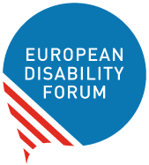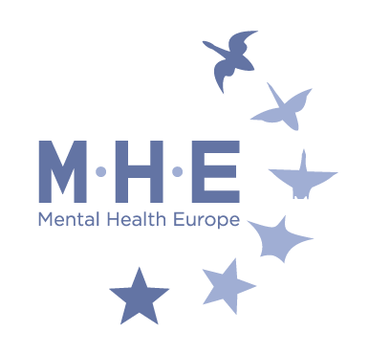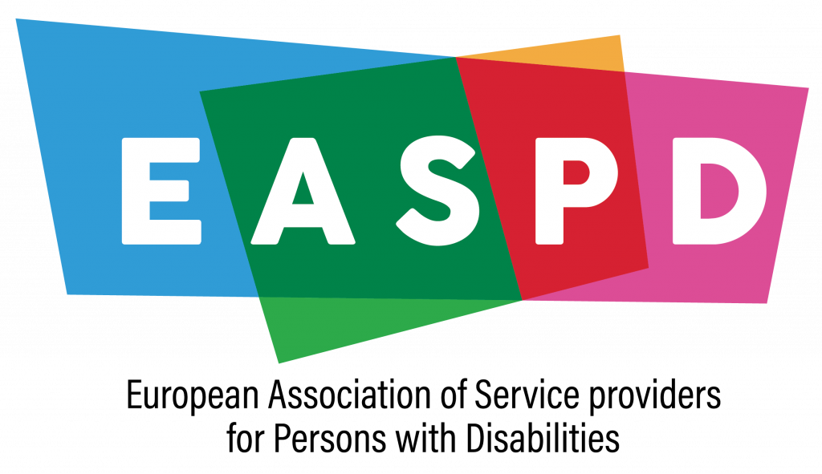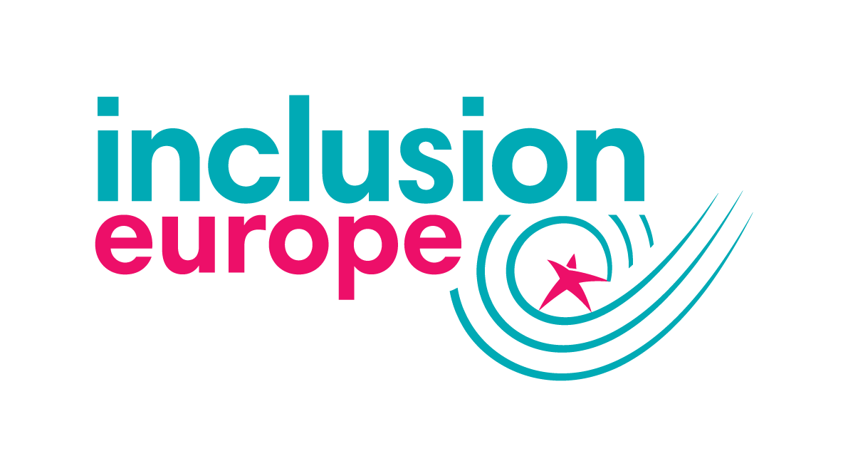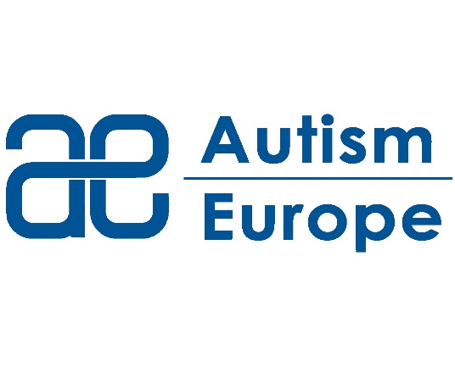
Brussels, 6th of June 2023

Subject: civil society joint position on the draft recommendation for the promotion of voluntary measures - CD-BIO meeting of 7th of June 2023

The European Disability Forum (EDF), Mental Health Europe (MHE), Inclusion Europe, the European Network of (Ex-)Users and Survivors of Psychiatry (ENUSP), the Validity Foundation, Autism-Europe, the European Association of Service Providers for Persons with Disabilities (EASPD), the Society of Social Psychiatry P. Sakellaropoulos and the International Disability Alliance welcome the continuation of the work of the CD-BIO on the request of the Committee of Ministers to affirm commitment to improving protection and the autonomy of persons in mental health care services.

We particularly welcome that our request was taken into account in the present draft of the Recommendation to refer to the United Nations Convention on Rights of Persons with Disabilities (CRPD), with reference we trust, to the WHO Quality Rights Initiative.

However, with regret we note that the present draft of the Recommendation departs from the request of the Committee of Ministers to create a draft recommendation promoting the use of voluntary measures in mental health care services. While the present draft Recommendation aims to ensure respect for autonomy in the provision of mental healthcare, in comparison to the first version of the draft, it lacks mechanisms on how to ensure the decrease and ultimate elimination of coercion in mental healthcare. It remains unclear how the Bureau reached the decision to so significantly depart from the objective set by the Committee of Ministers since none of the delegations of the State Parties proposed such a change.

We would like to recall that the Committee of Ministers also directed the CD-BIO to involve our respective organisations to participate in the work of the CD-BIO for the sole purpose of the fulfillment of drafting said Recommendation. While our organisations have indeed been invited to the meetings and provided our comments, we regret that almost none of our proposals have been accepted and that we received no feedback from the Bureau on our proposals. Our participation in this process was therefore, and once again, not meaningful.

As we stated at the last CD-BIO meeting in November 2022, the said Recommendation is necessary to reform European mental health systems in line with the obligations undertaken by 45 of the 46 Member States of the Council of Europe under the CRPD. However, such a recommendation must be fully aligned with CRPD and focus on principles and measures to not only decrease coercion in mental healthcare services, but have the objective to completely eliminate such human rights violations.

Therefore, in particular, we call on CD-BIO to:

- Set the objective of the Recommendation to decreasing and ultimately eliminating coercion in mental healthcare services and introduce effective mechanisms to that objective;
- Include reference to the WHO QualityRights Initiative in the Preamble of the Recommendation;
- Remove the reference to the principles of Rec(2004)10 concerning the protection of the human rights and dignity of persons with mental disorder, since the latter reinforces coercion in mental healthcare settings and is outdated;
- Remove all mention of the draft additional protocol to the Oviedo Convention, which has not been adopted by the Council of Europe;
- While acknowledging the need to eliminate involuntary measures, remove all mention of involuntary measures as a last resort (currently covered under article 3(2) of the draft document);
- Extend the scope of the recommendation from exclusively healthcare institutions (e.g. psychiatric hospitals) to mental health and social service providers who work with persons with mental health problems in residential settings and in the community;
- Include clear reference to the right to self determination - to recovery-oriented services and to access to advocacy, if needed;
- Stress the ultimate objective to eliminate coercion in mental health care and social services and improve States’ compliance with international human rights standards and current international recommendations and practices;
- Ensure that our respective organizations can meaningfully participate in the continued work on the draft Recommendation in line with Article 4(3) UN CRPD and the instructions of the Committee of Ministers.

We remain at your disposal for further discussion, including a separate meeting with the Bureau and with Dr. Elaine Gadd, the consultant supporting this work.

Sincerely,

Yannis Vardakastanis, President of European Disability Forum and President of the International Disability Alliance

Kristijan Grđan, Vice-President of Mental Health Europe

Steven Allen, Executive Director of the Validity Foundation

Olga Kalina, Chair of the European Network of (Ex-)Users and Survivors of Psychiatry

James Crowe, President of European Association of Service providers for Persons with Disabilities

Harald T Neerland, President of Autism-Europe

Jyrki Pinomaa, President of Inclusion Europe

Athina Fragkouli, President of the Board of the Society of Social Psychiatry P. Sakellaropoulos
Dr. Fiona Morrissey, Disability Law Researcher, Adjunct Lecturer-University of Galway, Lecturer-ATU Galway, Ireland

