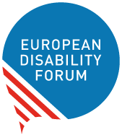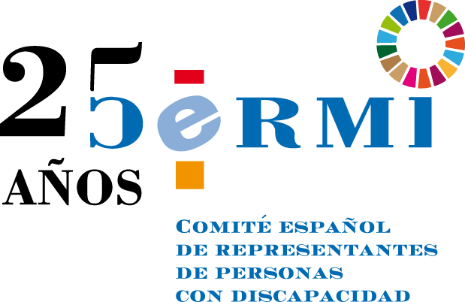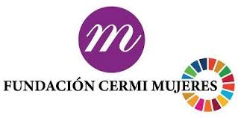
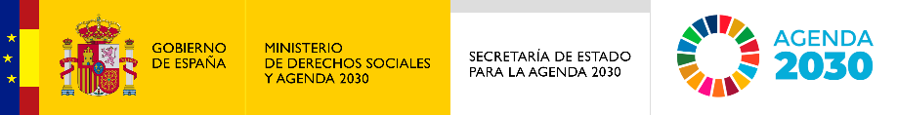

#OurFuture

Conference of and on women and girls with disabilities

Friday 22nd of April 2022
11.00 to 13.00 CET

About the Conference
The European Disability Forum, CERMI and CERMI Women’s Foundation organise an online conference on women and girls with disabilities. The #OurFuture Conference will feed into the Conference on the Future of Europe and EDF’s work on the rights of women and girls with disabilities in light of the 25th year anniversary of the organisations.
There are over 60 million of women and girls with disabilities in Europe. More than often, women and girls with disabilities are not included in public debates. Their concerns and needs are neither heard nor addressed in the development of laws, policies and initiatives at international, European and national level.
This conference will offer a platform to organisations of persons with disabilities, women with disabilities and women providing support to relatives with disabilities to interact with policy-makers, and raise their concerns to contribute to the future of Europe. Participants are encouraged to send their questions to policy makers in advance, and will also have the opportunity to raise them during the event.
The Conference on the Future of Europe is a citizen-led series of debates and discussions that will enable people from across Europe to share their ideas and help shape our common future.
Registration link: https://us06web.zoom.us/webinar/register/WN_d9u35nhsSpuSj9ztAD9M3A

Accessibility settings
The conference will be in English and Spanish.
International sign interpretation and live captioning in English and automatic captioning in other languages will also be provided.
Participants must indicate their request for automatic captioning in language of their choice when filling the registration form.

Programme
Moderated by: Ana Pelaez Narvaez, EDF Vice President, and Marine Uldry, EDF Human Rights Officer
11:00 – 11:10 Opening and introduction
- Yannis Vardakastanis, EDF President
11:10 – 12:00 Current state of play for women and girls with disabilities in Europe
Moderated discussion on the current issues faced by women and girls with disabilities in Europe and work of the EU institutions and bodies.
- Gunta Anca, European Disability Forum Executive
- European Commission, TBC
- María Eugenia Rodríguez Palop, Member of the European Parliament, Vice-Chair of the Committee on Women’s Rights and Gender Equality
- Jolanta Reingarde, EIGE Senior researcher, Research and Statistics team leader, European Institute for Gender Equality (EIGE)

Interactive discussion with participants
12:00-12:10 Break
12:10-12:50 Reflecting on the inclusion of women and girls with disabilities in the European movement and #OurFuture
Intervention by organisations of persons with disabilities across Europe

- Spain: Comité Español de Representantes de Personas con Discapacidad (CERMI), Pilar Villarino Villarino
- France: Femmes pour le Dire, Femmes pour Agir – Claire Desaint
- Croatia: Croatian Union of Associations of Persons with Disabilities (SOIH) – Marica Miric
- Italy: Italian Disability Forum – Luisa Bosisio Fazzi
- Greece: National Confederation of Disabled People, Antonia Pavli
- Netherlands: Feminists Against Ableism
12:50-13:00 Closing

